

Request for Quotation
Sports Pitch Drainage Works at Goffs Lane & Hammond Street Playing Fields

February 2026

Table of Contents
1. Introduction AND BACKGROUND 1
2. TERMS AND CONDITIONS OF THIS Request for QUOTation 2
4. EVALUATION AND Contract Award 9
Schedule 1 - Tenderer Information Questionnaire 13
Schedule 2 – qUALITY SUBMISSION 14
Schedule 3 - PRICING SCHEDULE 15
Schedule 4 - FORM OF tender 16
Schedule 5 - ADDITIONAL DOCUMENTS 18
Schedule 6 - GLOSSARY 19

For further information contact the contracting officer:

Dave Renouf
Green Spaces Manager
Broxbourne Borough Council
Bishops’ College
Cheshunt
Herts EN8 9XB
T – 01992 785555
E – dave.renouf@Bestbob.co.uk

- Introduction AND BACKGROUND
  - The Requirement
  - Broxbourne Borough Council (“the Council”) has a requirement for improving Public Health and wishes to appoint a suitably qualified and experienced organisation to undertake sports pitch drainage works at Goffs Lane and Hammond Street Playing fields, more particularly defined in the Specification set out in Schedule 5.
  - You are invited to submit a Tender in response to the contents of this Request for Quotation (“RFQ”).
  - This document sets out the information and instructions for the submission of Tenders. Tenderers should refer to and must comply with the specification at Schedule 5 when responding to this RFQ.
  - The Council will be the contracting authority for the purposes of any Contract resulting from this RFQ. This Procurement is conducted as a below threshold procurement for the purpose of procuring the works.
  - Certain words in this RFQ are capitalised. These are defined in the Glossary at Schedule 6.
  - Background Information
  - As part of the council’s capital programme for Improving Public Health the Council wishes to appoint a suitably qualified and experienced organisation to undertake sports pitch drainage works at Goffs Lane and Hammond Street Playing fields.
  - The National Procurement Policy Statement
  - The Council has had regard to the National Procurement Policy Statement in the design of this RFQ.
  - The Council’s Requirement
    - Goffs Lane Playing Fields EN7 5GA and Hammond Street Playing Fields EN7 6PN are large and highly significant playing fields located in West Cheshunt. As part of Improving Public Health the Council wishes to upgrade the existing football pitches by installing a drainage system by this tender and invites suitable companies to price for delivering the proposed works.

  - The Contract
    - The successful Tenderer will be required to enter into the Council’s Contract as available on the Council’s website.
    - The Council is not able to accept any alternative forms of contract.
Value of the Contract
    - The estimated total contract value of the Contract(s) is £96,000.00
  - Contract term
    - The Contract(s) will be offered on a basis of:
      - An exact work start date will be mutually agreed as part of the award of contract. The Council is keen for the work to be completed over a two-month period by the end of July 2026.
- TERMS AND CONDITIONS OF THIS Request for QUOTation
  - The following terms and conditions set out how the Council will conduct and how the Tenderer will participate in the Procurement. By submitting a Tender, Tenderers agree to be bound by these terms and conditions.
  - The Council may require Tenderers to confirm that their Tender remains accurate at any stage of the Procurement and to take appropriate action should that no longer be the case.
  - Tenderers must submit their completed Tender by 12:00pm Monday 9 March 2026
  - A completed Tender must include:
    - A completed Tenderer Information Questionnaire (Schedule 1);
    - The Quality submission (Schedule 2);
      - Tenderers are required to detail their approach and/or methodology proposed to fulfil the requirements for the delivery of these works.
    - The Pricing Submission (Schedule 3);
      - Your Pricing Submission must be in pounds sterling.
      - Tenderers must provide a fixed price quote breakdown of all costs for the delivery of the works to the Council including all costs and expenses (excluding VAT).
    - Your Form of Tender (Schedule 4);
The Council’s minimum requirements
  - the Council may consider any relevant information on the Debarment List about the Tenderer and any identified subcontractor, subconsultant, group or consortium member which the Tenderer intends to rely upon to perform the Contract (each a ‘Relevant Entity’). The Council may disqualify a Tenderer if the Tenderer or a Relevant Entity has been entered onto the Debarment List having regard to the reasons for the debarment.
  - To be eligible to be awarded a Contract, the Tenderer must meet certain minimum requirements. The successful Tenderer will be required to maintain the minimum requirements for the duration of the Contract as set out below:
    - Public / Product Liability: £10 Million
    - Public Indemnity: £5 Million
    - Employers Liability: £10 Million
  - Tenderers will also be required to comply with the following minimum requirements to participate in this Procurement and the awarded Contract:
    - Suitably experienced and knowledgeable in installation of sports pitch drainage systems
  - Tenders must be completed and submitted in their entirety via In-tend by the deadline set out in the Procurement Timetable at section 2.9.
The Procurement Timetable
  - Set out below is the proposed indicative Procurement Timetable for the award of the Contract. The Procurement Timetable is given below but may be changed by the Council at any time. Any changes to the timetable will be communicated to Tenderers via In-Tend as soon as practicable.

KEY EVENT | DATE
Advertisement of Tender Opportunity | 2 February 2026
Deadline for queries | 12 pm on Monday 2 March 2026
Responses to queries circulated | Wednesday 4 March 2026
Closing Date for Tender Submissions | 12:00pm Monday 9 March 2026
Notification of Award | Week commencing 16 March 2026
Completion of Contract | 31 July 2026

  - The Council may at any time amend this RFQ, suspend or terminate the Procurement or procure the Contract by other means, to award a contract without prior notice, to change the basis, the procedures and the timescales set out in this Procurement.
  - The Council reserves the right to issue further, supplementary documents throughout the Procurement, or to modify expand or replace existing documentation as referred to in this ITT, and such new or revised documents will be made accessible to all Tenderers.
Clarifications or Queries relating to the Procurement
  - Any questions or other requests for information in relation to this requirement should be submitted through the Supply Hertfordshire e-procurement portal at https://in-tendhost.co.uk/supplyhertfordshire by the deadline for Clarifications set out in the Procurement Timetable.
Tenderer must keep its information up to date
  - The Tenderer is responsible for maintaining and ensuring any information supplied to the Council (whether through the Central Digital Platform or In-tend) is kept up to date. The Tenderer must notify the Council of any changes to the information supplied immediately. The Council reserves the right to request any additional information or disqualify a Tenderer from the Procurement where the updated information affects the Tenderer’s Tender.
Not An Offer
  - By issuing the RFQ, the Council is not bound in any way and does not have to accept any Tender. The Council is not obliged to accept the lowest priced Tender.
The Council is not responsible for costs
  - Tenderers are solely responsible for their costs and expenses incurred in connection with the preparation and submission of their Tenders and any further stages of the Procurement. Under no circumstances (including circumstances where the Council cancels or varies the Procurement) will the Council or any of its advisers be liable for any costs or expenses borne by the Tenderers or their advisers.
Errors in Tender submissions
  - The Council has no liability to Tenderers arising from any errors in a Tenderer’s Tender or if the Council does not identify or notify a Tenderer of an error in a Tenderer’s Tender.
Disqualification for inducement
  - The Council reserves the right to disqualify (without prejudice to any other civil remedies available to the Council and any criminal liability which such conduct may attract) any Tenderer who does anything which would constitute a relevant breach of the Bribery Act 2010 or attempts (or whose advisers attempt) to influence the Procurement in any way.
Disqualification for collusion
  - The Council reserves the right to disqualify any Tenderer:
    - who enter into any agreement or arrangement with any other person as to the form or content of any other Tender, or offer to pay any sum of money or valuable consideration to any other person to effect changes to the form or content of any other Tender; or
    - who enter into any agreement or arrangement with any other person that has the effect of prohibiting or excluding that person from submitting a proposal, or affect the price submitted in the Tender by the Tenderer or any other person.
Validity of your Tender
  - Tenders must remain valid and capable of acceptance for 120 days from the closing date for receipt of Tenders.
Request for Information by the Council
  - The Council reserves the right to request any information in relation to a Tenderer’s Tender at any time during the Procurement, including but not limited to:
    - documentary evidence relating to those aspects of the Tenderer’s Tender which are based on self-certification;
    - documentary evidence on the Tenderer’s eligibility to tender and qualifications; or
    - financial data, such as audited accounts.
  - The Tenderer must provide the requested information within 5 working days of the Council’s request unless otherwise specified by the Council.
Variant Tenders
  - Tenderers who submit a variant Tender will be disqualified.
Publicity
  - Tenderers are not permitted to undertake any publicity activities regarding the works or the award of any Contract during the Tender without the prior written approval of the Council.
Abnormally low proposals
  - If it appears to the Council that any Tender may be abnormally low, then the Council may ask the Tenderer to explain its price or costs. If following the Tenderer's explanations, the Council is not satisfied with the Tenderer's account for the low level of price or cost in the Tender, the Council may treat the Tender as non-compliant and disqualify it.
Tenderer’s warranties
  - In responding to this RFQ, the Tenderer warrants, represents and undertakes that:
    - it understands and has complied with the terms and conditions set out in this RFQ;
    - all information, representations and other matters of fact communicated (whether in writing or otherwise) to the Council by the Tenderer, its staff or agents in connection with or arising out of the Procurement are true, complete and accurate in all respects, both as at the date communicated and as at the date of the submission of the response to this RFQ;
    - it has made its own investigations and undertaken its own research and due diligence, and has satisfied itself in respect of all matters (whether actual or contingent) relating to the invitation and has not submitted its response in reliance on any information, representation or assumption which may have been made by or on behalf of the Council (with the exception of any information which is expressly warranted by the Council)
    - it has full power and authority to respond to this RFQ and the Procurement and to perform the full obligations in relation to the Contract and will, if requested, promptly produce evidence of such to the Council
Confidentiality and Freedom of Information
  - The Council is required to publish certain contracts in accordance with its transparency obligations.
  - If a Tenderer considers part of its Tender is commercially sensitive, it should inform the Council via In-tend and:
    - identify any such information as commercially sensitive;
    - explain the potential implications of disclosure of such information; and
    - provide an estimate of the period of time during which the Tenderer believes that such information will remain commercially sensitive.
  - If a Tenderer identifies information as commercially sensitive in accordance with 2.11 above, the Council will try to maintain confidentiality over it. However, notwithstanding the Tenderer has identified information as commercially sensitive, the Council:
    - Routinely publishes the details of its contracts and the identities of its suppliers on https://www.broxbourne.gov.uk/democracy/transparency-information/8;
    - is subject the Environmental Information Regulations 2004 and has adopted the processes in the Freedom of Information Act 2000 and all information supplied to the Council may be disclosed in response to a request made pursuant to the Freedom of Information Act 2000 or the Environmental Information Regulations 2004;
    - is required to publish information relating to the Contract in accordance with Government policy on the disclosure of information relating to public contracts;
    - may disclose the content of any references sought from banks, existing or past clients, or other referees submitted by the Tenderer to other contracting authorities (as defined by Procurement Act 2023); and
    - may disclose within the Council and to other contracting authorities any Tender documents or information in them to assist performance monitoring and enforcement of the Procurement Act 2023.
  - All information supplied to Tenderers by the Council, including this RFQ and all other documents relating to this Procurement, either in writing or orally, must be treated in confidence (unless the information is already in the public domain) and must not be disclosed to any third party other than is strictly necessary for the purposes of preparing a Tender.
  - The Council is required to publish contracts in accordance with its transparency obligations. The Council may, at its sole discretion, redact some sections to protect commercially sensitive information or other information which it considers inappropriate to publish. The successful Tenderer may specify information it wishes to be redacted in the Commercially Sensitive Information schedule of the Contract.
Third Parties
  - Nothing in these terms is intended to confer any rights on any third party under the Contracts (Rights of Third Parties) Act 1999.
Disqualification
  - The Council reserves the right, at its discretion, to reject or disqualify a Tenderer where:
    - a Tenderer contravenes any of the terms and conditions of this Procurement;
    - the Tender is submitted late, completed incorrectly, is in any way incomplete or fails to meet the requirements which have been notified to Tenderers;
    - the Tenderer no longer meets the Council’s minimum requirements;
    - the Tenderer is guilty of serious misrepresentation or of negligently providing misleading information in relation to its Tender or the Procurement;
    - the Tenderer has obtained an unfair advantage, either through participation in market engagement or through a conflict of interest, that cannot otherwise be avoided; or
    - the Tenderer breaches the terms and conditions for use of In-tend.
- BIDDER QUESTIONNAIRE
  - Tenderers must complete the Tenderer Questionnaire in Schedule 1 and submit as part of their Tender.
- EVALUATION AND Contract Award
  - Any Contract awarded as a result of this Procurement will be awarded on the basis of the offer that is the most advantageous proposal to the Council. Tenders will be evaluated on:
    - The Quality Submission, weighted 40%; and
    - The Price Submission, weighted 60%.
[Evaluation of the Quality Submission
  - Tenderers must complete Schedule 2 (Quality Submission). The following matrix will be used to assess the Quality Submission.

Assessment | Score | Marking Criteria
Unacceptable | 0 | The information required is either omitted or fundamentally fails to meet and address the relevant submission requirements or there is insufficient demonstration of the Council’s requirements to enable the Council to evaluate.
Weak | 1 | The information submitted provides a demonstration that a minority of the Council’s requirements relevant to the question can be met. The Council has major concerns.
Poor | 2 | The information submitted provides a demonstration that that a majority but not all of the Council’s requirements relevant to the question can be met. The Council has some major concerns.
Acceptable | 3 | The information submitted provides a demonstration that all the Council’s requirements relevant to the question can be met subject to minor concerns. The Council has no major concerns.
Good | 4 | The information submitted provides a demonstration that all the Council’s requirements relevant to the question can be met. The Council has no concerns.
Outstanding | 5 | The information submitted provides a demonstration that all of the Council’s requirements relevant to the question can be met. The tenderer’s proposal adds value which is relevant to the Contract. The Council has no concerns.

  - The Written Submission will be awarded a weighting for an individual question by applying the following formula:
Tenderer’s score (%) = | Awarded score | x weighting
 | Maximum available score
  - Tenders will be evaluated under the headings shown in the table below:
Question | Description | Weighting
1 | Experience  - Please provide a summary of your firm’s experience of similar projects including working on sports pitch drainage schemes  - Please provide a summary of your project team and any sub-contractors | 20 marks
2 | Materials, Equipment and method  - Please provide a schedule of materials and equipment that will be used | 10 marks
3 | Project Management of Works  - Please provide project management process  - Please provide a proposed time scale and works programme | 5 marks
4 | Documentation  - Please provide a copy of your Health and Safety Policy along with relevant risk assessments, method statement and insurance documents. | 5 marks
5 | Financial  - Please provide a completed Schedule of Rates and Day work Rates | 60 marks

The Price Submission
  - The price submitted must be inclusive of all costs payable by the Council under the Contract. Tenderers must complete Schedule 3 (Pricing Submission).
  - The Price Submission will be evaluated on the following basis:
    - The Tender with the lowest price submitted will receive 100% of the available marks for the price evaluation 60% following weighting. All other Tender submissions will be compared against that lowest price by using the following calculation:
(lowest price submitted / Tender price) x 60% = available marks
    - The available marks will be rounded to the nearest two decimal places. For illustrative purposes only, where Supplier A submits a proposal price of £3,000, Supplier B submits £5,000 and Supplier C submits £7000 for the price weighting of 60%, the calculation for the Price Submission is as follows:
Supplier A: as the lowest price submitted, Supplier A receives the maximum available weighting for the Price Submission
Supplier B: (3,000 / 5,000) X 60% = 36.00 marks
Supplier C: (3,000 / 7,000) X 60% = 25.71 marks
- AWARD OF CONTRACT AND NOTIFICATION
  - Once the Council has reached a decision in respect of a contract award, it will notify all tenderers of that decision.
  - Contract award is subject to the formal approval process of the Council. Until all the necessary approvals are obtained, no Contract(s) will be entered into.

Tenderer Information Questionnaire

SCHEDULE OF WORKS

PRELIMINARIES

1 | The scope of works will include, but not necessarily be limited to, the following main operations:  Site enabling works – both sites.  · Establish site access.  · Establish site compound.  · Supply and install Heras perimeter fencing.  Pipe drainage – Goffs Lane (Option 1)  · Install pipe drainage system with lateral drains installed at 4m centres.  · Connection of the drainage system to an outfall located in the southeast corner of the pitch 1 and eastern side of pitch 2.  Pipe drainage – Hammond Street (Option 1)  · Install pipe drainage system with lateral drains installed at 4m centres.  · Connection of the drainage system to outfalls located in the northeast and southeast corners.  Pipe drainage – Goffs Lane (Option 2)  · Install pipe drainage system with lateral drains installed at 6m centres.  · Connection of the drainage system to an outfall located in the southeast corner of the pitch 1 and eastern side of pitch 2.  Pipe drainage – Hammond Street (Option 2)  · Install pipe drainage system with lateral drains installed at 6m centres.  · Connection of the drainage system to outfalls located in the northeast and southeast corners. | Description of Work
2 | The contract will be based on this specification. Any subsequent changes agreed between the contractor and Supervising Officer will be made in writing. | Contract
3 | The works will be inspected during the twelve (12) months following completion and the contractor will be required to make good at his own expense any defects which may have arisen due to poor materials or workmanship and make up any settlement. | Defects Liability Period
4 | The contractor shall take his own site dimensions for materials, fittings and equipment for use in the works. | Site Dimensions
5 | The pitches will be closed during the works and notices to this effect. The contractor will supply, erect and maintain suitable barriers to close off the sections of the route where work is in progress. | Occupation
6 | Allow for the protection as necessary and for making good any damage caused to the natural environment including grassland as well as public or private roads and paths and general paved surfaces in the area. | External Protection
7 | Provide for all costs in connection with labour, materials, plant, transport and all other things necessary for the proper execution of the works. | Provide Everything Necessary
8 | The contractor shall keep on site at all reasonable times a working foreman or other responsible person to whom the supervising officer can give instructions and who can co-ordinate the work of other operatives and sub-contractors. | Foreman
9 | Access for site vehicles is available via public roads and private tracks. The contractor will liaise with the Supervising Officer over access and locations for the delivery and storage of materials. | Access
10 | The contractor will only take instructions from the supervising officer unless advised otherwise by that named officer. | Instructions
11 | Before starting work the contractor will comply with the Health and Safety requirements of the Borough of Broxbourne. This will include provision of appropriate risk assessments and proof of Public Liability insurance cover of £10 million, Employers Liability cover of £10 million and Professional Indemnity cover of £5 million. | Health and Safety and Insurance
12 | The supervising officer may, without invalidating the contract, order an addition or omission to the works. The supervising officer will issue written instructions regarding these variations. | Variations
13 | The contractor is to include in his price any additional works that he believes necessary to ensure the specification achieves the intended outcomes of the contract. | Additional works
14 | Overnight parking for contractor’s vehicles will be available on site by agreement. The site cannot be guaranteed as secure and the contractor will be responsible for all his plant and equipment whilst it is on site. | Site Vehicles
15 | Work not backfilled at the end of the day will be protected. A method statement will be provided, in advance of the pre-contract meeting, to detail the phasing and direction of works. | Public Safety and Phasing of Work
16 | The contractor will be responsible for surveying the site prior to commencement of works to identify and avoid damage to any services including those underground. In the event of any damage occurring, the contractor will be held liable for any repairs. | Existing Services
Dimensions and Tolerance – Goffs Lane Playing Fields

- S201 Pipe drainage system
- Where required, lateral and main drains are to be installed to the invert level as shown on drawings J006634 003 or depths set out in section S300.
- The position of the internal face of any pipeline shall not deviate from that shown in the drawings by more than the tolerances detailed below:
- From the existing gradient: + or – 20 mm
- From the line of the drain + or – 50 mm
- Where feasible, pipelines shall be laid at a uniform gradient or shall generally follow the natural gradient of the land.
- Overall pipeline gradients shall not differ from the required gradients by more than 10% e.g. for a specified grade of 1 in 50 pipes laid at between 1 in 45 and 1 in 55 will be acceptable provided the other criteria above are also satisfied.
Dimensions and Tolerance – Hammond Street Playing Fields

- S201 Pipe drainage system
- Where required, lateral and main drains are to be installed to the invert level as shown on drawings J006634 003 or depths set out in section S300.
- The position of the internal face of any pipeline shall not deviate from that shown in the drawings by more than the tolerances detailed below:
- From the existing gradient: + or – 20 mm
- From the line of the drain + or – 50 mm
- Where feasible, pipelines shall be laid at a uniform gradient or shall generally follow the natural gradient of the land.
- Overall pipeline gradients shall not differ from the required gradients by more than 10% e.g. for a specified grade of 1 in 50 pipes laid at between 1 in 45 and 1 in 55 will be acceptable provided the other criteria above are also satisfied.
4.0 SCOPE OF WORKS
Goffs Lane and Hammond Street Playing Fields

T S302 Pitch drainage system

1.GENERAL

The aim of the proposed primary drainage works is to create an intensive and uniform network of lateral drains across the entirety of the playing area.

Drainage pipework shall consist of perforated, corrugated plastic pipe lateral drains conforming to BS 4962 or twin wall pipe main drains to BBA industry standards as appropriate, with the Kite Mark clearly shown. Drains shall be installed in accordance with drawings listed in S202. All junctions and connections shall be formed with purpose made fittings of appropriate size. Install pipe drainage system with 80 mm lateral drains at 4m or 6m centres on the pitch areas. All drain runs shall be tested for line and gradient prior to backfilling.

The Contractor shall inspect each site and satisfy themselves as to the ground conditions. Lateral drain trenches shall be a minimum width of 150 mm, but the Contractor shall allow for excavating trenches as wide as necessary with the appropriate machinery.

All main drains and laterals shall be laid at the invert levels shown on the drawings.

2. DRAINAGE TRENCH EXCAVATION

Drains shall be installed within the pitch area using conventional perforated corrugated pipe or fully perforated twin wall pipe where appropriate.

Excavate topsoil and subsoil to form drain trenches to the required depth and shape the trench bed to receive pipes.

Drainage arisings shall be removed from the working area/off site or used to blend in any areas within the site if required, only in agreement with the Employer’s Representative.

The drains shall be installed with the fall of the land or where shown on the drawings at the invert depths indicated. The trench bases shall be shaped to bed, fit and secure the pipes centrally at the required depth. Minimum pipe invert levels are as follows:
J006633
Pipe size (mm) Minimum invert depth from finished surface (mm)
- 80 mm upvc perforated 600
- 100 mm upvc perforated 600
- 150 mm upvc perforated 600
- 225 mm unperforated 725
Lateral drain trenches shall be excavated to provide a smooth, even fall along their line at the specified depth, adjusting the depth to form a smooth junction with the main drains. Trenches shall not deviate from the line of the drain by more than the tolerances stated.

The main drains shall be installed deep enough to provide for connection of any lateral drains and/or carrier drains. The drains shall follow the natural fall of the ground with no abrupt changes in the gradient. Subsoil material from the main drain arisings shall be removed from the working area/off site or used to blend in new platform (if required).

3. PIPES AND BACKFILL MATERIALS

Flexible perforated plastic pipes shall conform to BS 4962. Where specified twin walled pipes shall be high density polyethylene pipes conforming to industry standards. The pipes shall have a smooth internal wall and corrugated outer wall and shall be perforated except where otherwise specified.

The diameter of lateral drains and main drains shall be as shown on the drawings listed in S202.

All joints and junctions in the drains and connections between the drains shall be made using purpose made fittings of appropriate size to form closely fitting joints between the pipes with no gaps. Purpose made end caps shall be fitted and secured to the upper end of all open pipes to prevent ingress of soil or aggregate material. The aggregate used for backfilling the trenches over pipe drains shall be a clean, hard wearing 2-6 mm gauge material resistant to abrasion or breakdown.
The calcium carbonate content shall not exceed 5%. The aggregate shall not contain particles that are flaky, laminar or platy in shape, or susceptible to breakdown during working by machinery. The aggregate shall be tested in advance of the works with laboratory analysis reports submitted to the Employer or Employers representative. Drain trenches shall be backfilled up to 150 mm from ground level using the approved 2-6 mm gauge aggregate. Adequately and evenly firm to prevent settlement leaving surface flat.

Cover the 2-6 mm gauge aggregate to the surface with 150 mm firmed depth of an approved imported rootzone material and consolidate during placement and again on completion.

Backfilling material to bring the trench up to ground level shall be an approved sand:compost mix with an 80:20 ratio of sand to compost. The Contractor shall insure the sand used within the rootzone mix provides the correct bridging factors with the underlying gravel.

The contractor shall allow for returning to site to top up any drain lines which have sunk because of settlement prior to the handover to the client.

Pipes shall not be installed in temperatures less than those specified by the pipe manufacturer.

Pipe drainage trenches should be backfilled with the above mentioned 2-6 mm gravel within 150 mm of the surface level. Backfill the remainder of the trench to ground level with an approved sand:compost mix material. All backfilling materials shall be adequately and evenly firmed to prevent settlement.

Backfilling shall be carried out without disturbing or damaging pipe drains or junctions. Where any haulage routes cross drains previously installed, protective boards shall be placed over the drain trenches to prevent damage or contamination with subsoil material. Drain trenches that are subject to traffic shall be made good afterwards to ensure that the drains comply with the specification.

Backfilling shall be carried out as drain installation progresses. Trenches shall not be left open overnight.

4. SITE CHAMBERS

Excavate to required depth and construct silt chambers at locations shown on drawing J006634 003.

The minimum inside measurements shall be 900 mm x 600 mm and to a depth of 300 mm below the invert of the of the outlet pipe, except where otherwise specified.
Allowance shall be made for building in rigid inlet and outlet pipes and pointing and sealing around all units and pipes to ensure efficient waterproofing. Corrugated plastic pipes shall be sleeved in rigid pipe with a minimum length of 1.5 m fixed securely into the chamber wall.

Following construction of the chambers, the surrounding ground shall be reinstated by placing and consolidating subsoil in 150 mm thick layers. The inlet and outlet pipes shall be maintained at the required gradient and invert levels during backfilling. Topsoil shall be replaced to the minimum consolidated thickness of 150 mm.

The chambers shall be fitted with grade B cast iron covers and frames to BS EN 124:1994. The frames shall be bedded on and haunched in cement mortar. The covers shall be set 25 mm below the adjacent ground level.

5. OUTLET DRAIN

The contractor shall be responsible for making good the surface if settlement occurs on the trenches.

Following laying and sealing of the pipes, subsoil shall be replaced first and then the topsoil. Each material shall be adequately firmed to avoid settlement.
Allowance shall be made for breaking in and connecting to the silt chamber with pointing and sealing around all joints to ensure efficient waterproofing.

S303 Seeding of the drain lines Provide a seed mixture for sowing on the drain lines at a rate of 35 g/sqm.
100% Perennial ryegrass Certified seed of at least 3 cultivars with a mean
rating of no less than 7.4 for live ground cover and visual merit as published in Table S1 of the current Turfgrass Seed Booklet published by STRI/BSBP.

Note: Alternatives to the cultivars listed will only be approved before the tender is submitted or works commence on site. The seed mixture shall comply with the minimum standards set out in the seed regulations at the time of sowing and shall be approved by the Employer’s Representative prior to commencing the work.
Sow the grass seed during suitable conditions on top of the drain lines.

The seed shall be sown with a pedestrian dimple seeder to an agreed depth, or an alternative machine approved by the Employers Representative. Seeding depth may be changed by the Employer’s Representatives depending on the weather conditions prevailing at the time.

qUALITY Submission

QUESTION | WEIGHTING | RESPONSE
Experience  -Please provide a summary of your firm’s experience of similar projects including working on sports pitch drainage schemes  -Please provide a summary of your project team and any sub-contractors  Word Limit: N/A | 20 marks
Materials, Equipment and Method  -Please provide a schedule of materials and equipment that will be used  Word Limit: N/A | 10 marks
Project management of works  -Please provide project management process  -Please provide a proposed timescale and works programme  Word Limit: N/A | 5 marks
Documentation  -Please provide a copy of your Health and Safety Policy along with relevant risk assessment, method statement and insurance documents  Word Limit: N/A | 5 marks

PRICING SUBMISSION
Rates must include all materials, equipment, plant and labour
*As above, mentioned in Schedule of Works - Preliminaries 1. Please provide a schedule of rates for the option of both 4m and 6m centres.

 | Goffs Lane Playing Fields
Item | Description | Qty | Unit | Rate | Total
5.2.1 | Contract Preliminaries Transport & General Requirements | 1 | Item
5.2.2 | Setting out in accordance with the drawings | 1 | Item
5.2.3 | CAT Scanning | 1 | Item
5.2.4 | Heras fencing | 1 | Item
5.2.5 | 80 mm perforated laterals | 3000 | m
5.2.6 | 150 mm perfoated main | 365 | m
5.2.7 | Lateral/main junctions - 80 mm/150 mm | 64 | No.
5.2.8 | 225 carrier drain installation | 26 | m
5.2.9 | Removal of drainage arisings on site | 1 | Item
5.2.10 | 900x600 silt chamber | 5 | No.
5.2.11 | Provide as-built drawing | 1 | Item
5.2.12 | Topping up drain lines | 1 | Item
 | Subtotal for Pitch 1 Drainage Works (4m Centres)
 | Subtotal for Pitch 2 Drainage Works (4m Centres)
 | Subtotal for Pitch 1 Drainage Works (6m Centres)
 | Subtotal for Pitch 2 Drainage Works (6m Centres)
 | Total For Drainage works (4m Centres)
 | Total For Drainage works (6m Centres)

 | Hammond Street Playing Fields
Item | Description | Qty | Unit | Rate | Total
5.2.1 | Contract Preliminaries Transport & General Requirements | 1 | Item
5.2.2 | Setting out in accordance with the drawings | 1 | Item
5.2.3 | CAT Scanning | 1 | Item
5.2.4 | Heras fencing | 1 | Item
5.2.5 | 80 mm perforated laterals | 1868 | m
5.2.6 | 150 mm perforated main | 191 | m
5.2.7 | Lateral/main junctions - 80 mm/150 mm | 38 | No.
5.2.8 | 225 carrier drain installation | 44 | m
5.2.9 | Removal of drainage arisings on site | 1 | Item
5.2.10 | 900x600 silt chamber | 2 | No.
5.2.11 | Provide as-built drawing | 1 | Item
5.2.12 | Topping up drain lines | 1 | Item
 | Total For Drainage works (4m Centres)
 | Total For Drainage works (6m Centres)
SCHEDULE OF DAYWORK RATES FOR DRAINAGE WORKS

ITEM | QUANTITY | UNIT | RATES  £ p
1. PLANT
JCB OR (EQUIVALENT) WITH OPERATOR | 1 | 1 hour
TRANSIT VAN OR EQUIVALENT | 1 | 1 hour
MEDIUM SIZE DUMPER (3 TONNE OR SIMILAR) | 1 | 1 hour
TRACKED MINI- DIGGER | 1 | 1 hour
2. LABOUR
SUPERVISOR | 1 | 1 hour
LABOURER | 1 | 1 hour
PLANT OPERATOR/DRIVER | 1 | 1 hour
3. MATERIALS
PERCENTAGE ADDITION |  | %

FORM OF tender

BBC0226 Goffs Lane and Hammond Street Playing Fields Drainage Works
FORM OF TENDER: TENDER CERTIFICATE
TO: BROXBOURNE BOROUGH COUNCIL
DATE:___________
PROVISION OF: Sports Pitch Drainage Works at Goffs Lane & Hammond Street Playing Fields
REFERENCE NUMBER: OH7
We [INSERT NAME[S]] the undersigned, having examined the RFQ and all other schedules, do hereby offer to provide the description of works as specified in those documents and in accordance with the attached documentation to the Council commencing on a date mutually agreed and continuing for the period specified in the Contract.
We further undertake and it shall be a condition of any Contract, that:
- The amount or content of our Tender has not been devised or calculated by agreement or arrangement with any person other than the Council and that the content or amount of our Tender has not been communicated to any person until after the closing date for the submission of Tenders and in any event not without the consent of the Council.
- We have not canvassed and will not, before the evaluation process, canvass or solicit any member or officer, employee or agent of the Council or other contracting authority in connection with the award of the Contract and that no person employed by us has done or will do any such act.
- We have not offered, promised or given any person working for or engaged by the Council a financial or other advantage as an inducement or reward for any improper performance of a function or activity relating to this procurement.
We warrant that we have all requisite authority to sign this Tender and confirm that we have complied with all the requirements of the RFQ.
Signature | _______________________________________________
Name and status | _______________________________________________
Signature | _______________________________________________
Name and status | _______________________________________________
For and on behalf of | [NAME OF COMPANY, PARTNERS OR CONSORTIUM]

- : ADDITIONAL DOCUMENTS
Grading Curve – Sand Drianline Backfill
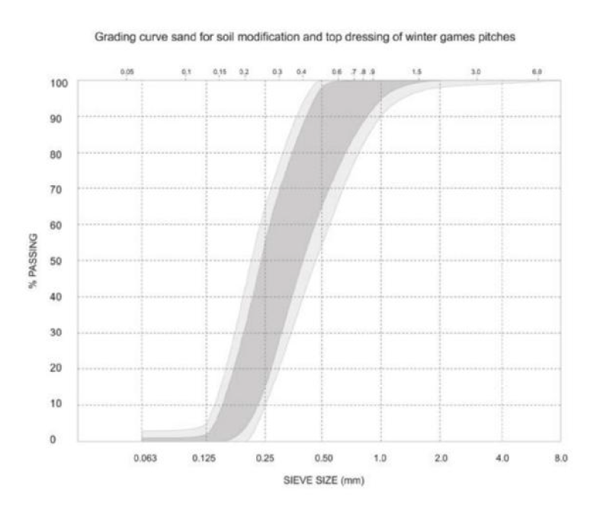
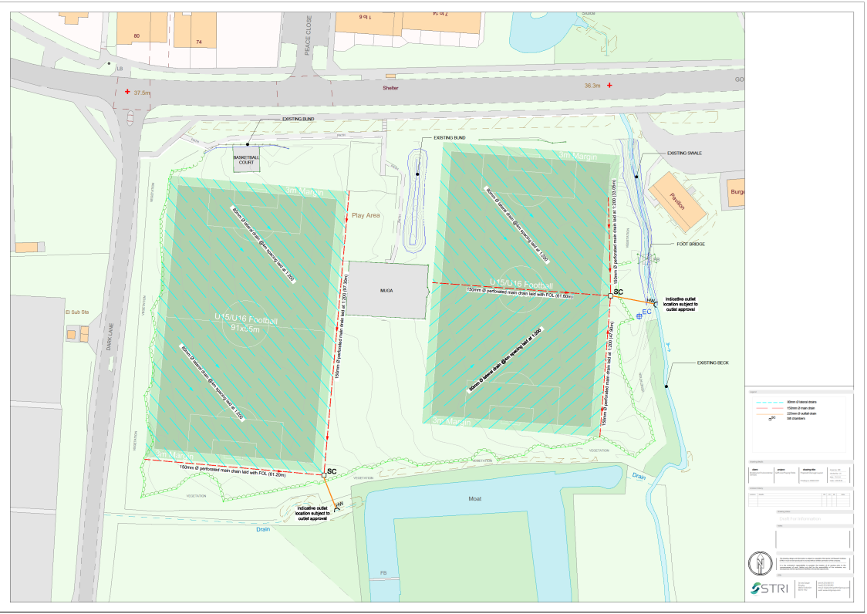
Proposed Drainage Layout – Goffs Lane Playing Fields

Proposed Drainage Layout – Hammond Street Playing Fields

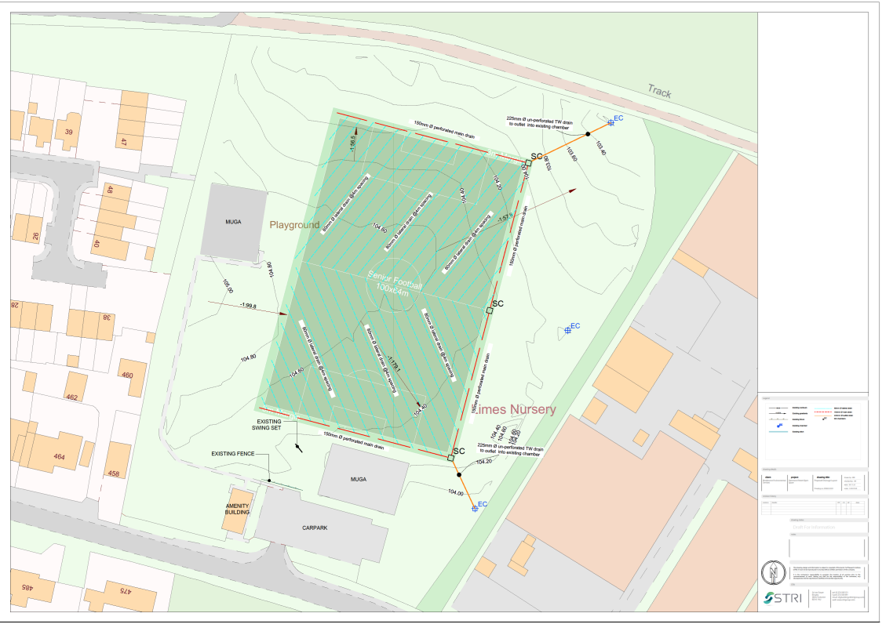

Schedule 6: Glossary
Tenderer(s) | Those (whether persons, firms or companies) tendering for the Contract.
Tenderer Questionnaire | The requirements as set out at 3.1 and Schedule 1 of this RFQ.
Contract | The contract which is entered into by the Council with the successful Tenderer following this procurement as set out at Schedule 5 of this RFQ.
Debarment List | The list of suppliers as maintained in accordance with Section 62 of the Procurement Act 2023.
FOIA | Freedom of Information Act 2000.
Goods | As defined in the Contract set out in Schedule 5 of this RFQ.
RFQ | This Request for Quotation including all appendices and schedules.
Price Submission | The requirements as set out at 4.5 - 4.6 and Schedule 3.
Procurement | The procurement of the works pursuant to Procurement Law in accordance with this RFQ.
Procurement Law | The Procurement Act 2023 and any regulations relating to procurement of goods, works and services to which the Council must comply (as amended from time to time).
Procurement Timetable | The timetable setting out the key dates for this Procurement, as at Section 2.9 of this RFQ.
Tender(s) | The proposal(s) submitted by the Tenderer(s) in response to this RFQ.
Quality Submission | The requirements as set out 4.2 - 4.4 and Schedule 2 of this RFQ.
Works | As defined in the Contract set out in Schedule 5 of this RFQ.
END OF DOCUMENT

