|  |  |
| --- | --- |
| **QUOTATIONS TO BE RETURNED TO:**  <https://in-tendhost.co.uk/tamworthbc> | **Invitation Date: 06 May 2025** |
| **IN THE EVENT OF ANY QUERIES, PLEASE USE THE CORRESPONDENCE FACILITY ON THE IN-TEND PORTAL** |

|  |
| --- |
| **INSTRUCTIONS TO PROVIDERS**  1. Quotations are requested for the provision of the Design, Installation & Maintenance of a Play area at Hamble  2. Quotations **MUST** be made in either pdf format or in a format which is compatible with Office 365 and documents submitted electronically via the in-tend portal at <https://in-tendhost.co.uk/tamworthbc> by:   1. **NOON on Tuesday 03 June 2025.** 2. Any problems uploading submissions **MUST** be reported to the Corporate Procurement Team (Tel: 01827 709371 Email: [procurement@tamworth.gov.uk](mailto:procurement@tamworth.gov.uk) before the submission deadline. Where a provider (the ‘Provider’) of a supply and/or service is unable to upload their submission and the report of the problem is received after the submission deadline, this will result in the disqualification of the submission. 3. Providers must complete the attached price schedule and provide any attached additional information requested. 4. The Provider agrees and accepts that any Quotation submitted by the Provider shall remain open for acceptance for a period of ninety (90) days from the closing date for the receipt of Quotations, and shall not alter, amend, vary or withdraw without the prior written agreement of Tamworth Borough Council (the ‘Council’). 5. Quotations other than on this form will not receive consideration. The Council reserves the right to disqualify Quotations received where the Quotation does not comply with the Specification or any other conditions as stated in the Invitation to Quote (ITQ) document and/or; does not include all documentation or information requested/required by the Council as stated in the ITQ document and/or; requires or implies any variation to the terms and conditions of the contract (the ‘Contract’) as set out in the ITQ document and/or includes Prices and/or Rates which are stated in the Provider’s Quotation as being subject to variation or are uncertain, imprecise or not presented in the form prescribed in the ITQ document. 6. The Council is not obliged or bound to accept the lowest or any Quotation. 7. The Council’s General Conditions of Contract for Provision of Goods & Services will apply to any subsequent Contract. Providers may view the Terms & Conditions on the Council’s website at <http://www.tamworth.gov.uk/budgets/spending/tenders-and-contracts>. Providers accept that by responding to this ITQ and in the event their Quotation is accepted, they will enter into and execute a Contract subject to the Terms and Conditions of Contract without amendment, deletion or addition. Providers also accept that by responding to this ITQ they are accepting that the Terms and Conditions of the ITQ and any subsequent Contract are in all circumstances fair and reasonable in all respects and the contractor (the ‘Contractor’) shall be bound by the Terms and Conditions of the Contract forthwith and with effect from the Commencement Date of the Contract. 8. Any correspondence or request for clarification related to this ITQ must be submitted in writing via the Correspondence facility on the In-tend portal. Any such requests must be made at least ninety-six (96) hours prior to the submission return time and date deadline. Queries and/or requests for clarification will NOT be answered after the 4 day deadline. Replies will be sent to all Providers as a Clarification Notice via in-tend, although the anonymity of the person raising the query will be maintained.   10. The Council is responsible for determining the IR35 status of a contractor where they fall under the definition of a personal services company, and will be required to deduct tax at source, including Pay As You Earn (PAYE) and National Insurance (NI), through the Real Time Information (RTI) system where appropriate. |

1. **Introduction**

The Council is seeking to appoint a Contractor with reputable knowledge and experience of design, installation and maintenance of playground equipment. The Contractor will carry out a full removal and replacement of the existing equipment, create a new play area and cover with a suitable safe surface and give clear, full guarantees for the new safety surface and the new play equipment.

The play area location is Hamble, Belgrave, Tamworth, Staffordshire, B77 2JE

What3words location ///songs.rats.fever

1. **SPECIFICATION**

**Play Area Design**

2.1 The Council requires a play area that is designed for an age range from toddlers to fourteen (14) year olds.

2.2 The successful design needs to encourage innovation in play design, giving a sense of freedom, exhilaration and risk taking, whilst being designed to fit the existing surroundings of the park. The successful submission will fully explain how this will be achieved.

2.3 All equipment needs to be accessible to all abilities and disabilities where possible, to offer a wide range of play experiences. Evidence of how this is achieved will be required within the submission.

2.4 Where new innovative equipment is suggested, we require contact information for parties where this equipment has already been installed, along with promotional material for the product and the relevant safety information.

**3. The Requirement**

3.1 The play area installation will meet the minimum requirements of BS EN 1176. Surfacing will meet the impact attenuating requirements of EN1177 and be tested in accordance with BS 7188.

3.2 The play area must include a fully constructed wet pour safety surface. Dimensions are flexible at this location but a suggested 10.5m x 7.5 m is recommended as a template.

3.3 Construction of the play equipment must not include wood, plastic or rope materials and all surfaces shall be smooth, durable and easily cleansed.

3.4 Due to the enclosed nature of this park the play area must not include any

equipment designed to emit loud noises that would exceed those of regular play.

**4. Health & Safety and site Access**

4.1 The Contractor shall maintain documentation to confirm all plant and equipment used at the site is routinely maintained by competent persons. In addition, the Contractor shall carry out risk assessments for all plant and equipment to be used at the site and maintain staff training and instruction records.

4.2 The Contractor shall ensure that the site is left secure at the end of each working day. All reasonable precautions shall be taken to prevent unauthorised access to the site and works at all times.

**5. Timelines**

5.1 From Award of Contract the installation of the play area is not expected to exceed 8 weeks.

**6. Maintenance**

6.1 The Contractor will include an appropriate two (2) year maintenance inspection programme for the installed play area apparatus and provide a full breakdown of warranties and what is covered and associated warranty time periods. A Post Installation Inspection must also be included in the price. The Contractor will allow for a maintenance induction to the site and equipment for our inspectors and maintenance contractor, this should include verbal recommendations for the maintenance regime for the site equipment.

**7. Budget**

7.1 The maximum budget available for this project is Thirty-Five thousand pounds (£35,000) excluding VAT. We expect the Contractor to make full use of the budget but not exceed it. This will also include the maintenance programme.

8. **Site Visit**

8.1 A site visit can be requested using the correspondence function in Intend.

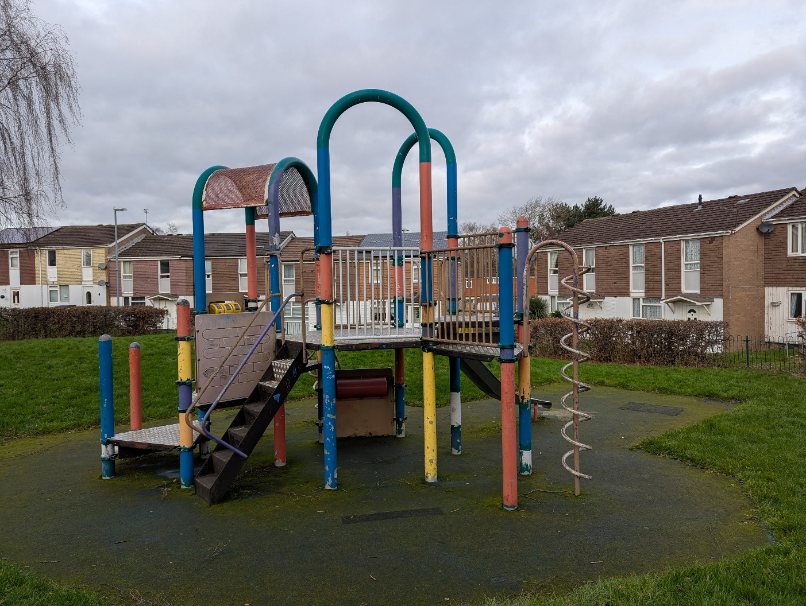

1. A playground in a park

   AI-generated content may be incorrect.

**EVALUATION GUIDANCE**

**What MUST be submitted by the Provider with their Quotation?**

Providers must include the following when submitting their Quotation:

1. A completed Additional Information Required form.
2. Sufficient information and detail to address the requirements described below under Section 2 – Quality for each listed criterion. Failure to provide the required information with your Quotation will result in your submission losing marks.
3. Sufficient information and detail to address the requirements described below under Section 3 – Social Value. Failure to provide the required information with your Quotation will result in your submission losing marks.

**Evaluation Procedure & Guidance**

The evaluation process will identify the most advantageous Quotation and the Contractor will be selected on this basis and the Contract awarded. As stated in paragraph 7 of the Instructions to Providers, the Council is not obliged or bound to accept the lowest or any Quotation.

The criteria to be used by the Council in the evaluation process will be those set out below which include:

|  |  |  |
| --- | --- | --- |
| **ITEM** | **CRITERIA** | **WEIGHTING** |
| **1** | **Quality** | **95%** |
| **2.** | **Social Value** | **5%** |

1. **QUALITY**

The overall weighting for Quality is 95%. This has been further broken down into the questions and weightings below.

|  |  |
| --- | --- |
| **Q1. Project Delivery** | **Weighting 20%** |
| Please explain your approach to delivering the project. Your response should include, but not be limited to:   * Your intended approach to delivering the project. * Milestones/Delivery Plan * Details of the Contract Manager assigned to our project. * Please explain how you will communicate and interact with the Council before, during and after project implementation. * Materials used * A description of the key risks envisaged and your mitigation proposals to ensure successful delivery of this project. * Warranty details   **Assessment Criteria**  **The level of which the Contractor has demonstrated and evidenced (including the use of Case Studies where relevant):**   * Clear, detailed, realistic proposals providing reassurance that all aspects of the project will be met. * Response demonstrates an understanding of the requirements set out in the specification. * Knowledge and understanding of key risks with effective proposals to mitigate. * Confirmation that you are able to comply with the project timelines identified in the Specification but if the Provider can complete the works sooner an approximate completion date must be included in their submission | |
| **Please respond below in no more than 1000 words** | |

|  |  |
| --- | --- |
| Q2. Play Area Design & Play Value | **Weighting 30%** |
| Providers must explain how their design meets the specification.  Providers will be expected to submit details of any play value they can deliver that will enhance the children’s experience of using the play area. | |
| **Please respond below in no more than 1000 words** | |

|  |  |
| --- | --- |
| **Q3 Accessibility** | **Weighting 25%** |
| Please explain how your submitted design is accessible and meets the requirements for play areas within the Disability Discrimination Act. | |
| **Please respond below in no more than 500 words** | |

|  |  |  |
| --- | --- | --- |
| **Q4 Case Studies** | | **Weighting 20%** |
| Please provide details of up to two contracts, to meet the technical and professional ability criteria set out in the ITQ documents, in any combination from either the public or private sector; voluntary, charity or social enterprise (VCSE), that are relevant to our requirement. VCSEs may include samples of grant-funded work. Where this procurement is for supplies or services, the examples must be from the past three years.  The named contact provided should be able to provide written evidence and before and after photographs to confirm the accuracy of the information provided below.  **For each contract, please provide the following information:**  ***Assessment Criteria:***   * Response provided including all information, * Examples are relevant in size & nature to the service outlined in the specification and demonstrates delivery of similar projects. * Track record of successful delivery | | |
| **Example 1** | | |
| **Name of customer organisation** |  | |
| **Point of contact in the organisation** |  | |
| **Position in the organisation** |  | |
| **E-mail address** |  | |
| **Description of contract (in no more than 300 words)** |  | |
| **Contract Start date** |  | |
| **Contract completion date** |  | |
| **Estimated contract value** |  | |
| **Example 2** | | |
| **Name of customer organisation** |  | |
| **Point of contact in the organisation** |  | |
| **Position in the organisation** |  | |
| **E-mail address** |  | |
| **Description of contract (in no more than 300 words)** |  | |
| **Contract Start date** |  | |
| **Contract completion date** |  | |
| **Estimated contract value** |  | |

Each criterion will be marked on a scale of 0 to 5. The table below sets out how these marks are allocated:

|  |  |  |
| --- | --- | --- |
| **0** | **Unacceptable** | Unable to assess due to the lack of evidence/unsatisfactory level of detail provided. The proposal does not demonstrate an understanding of the Council’s requirements and issues with the proposal either being non-compliant or with a major risk that the intended outcomes/ performance standards will not be achieved and delivered |
| **1** | **Poor** | The proposal demonstrates extremely limited understanding of the Council’s essential requirements, with a significant risk that the majority of the intended outcomes/ performance standards will **not** be achieved and delivered with the level of evidence in support of the proposal deficient in the majority of areas. Proposal shows significantly more weaknesses than strengths. |
| **2** | **Concern** | The proposal demonstrates some understanding and addresses some of the Council requirements. There is a risk that some of the intended outcomes/ performance standards will **not** be achieved and delivered with the level of evidence in support of the proposal deficient in certain areas and requires the reviewer to make assumptions. Proposal shows a balance of weaknesses and strengths. |
| **3** | **Acceptable** | The proposal demonstrates reasonable understanding of all or most of the Council requirements and issues and provides an acceptable degree of confidence that all or most of the intended outcomes/ performance standards will be achieved and delivered with an acceptable level of evidence in support of the proposal, but with some minor reservations. Proposal shows more strengths than weaknesses. |
| **4** | **Good** | The proposal demonstrates a good understanding of all of the Council’s essential requirements and issues and provides a high degree of confidence that all or most of the intended outcomes/ performance standards will be achieved and delivered with the level of evidence in support of the proposal fully meeting expectations. |
| **5** | **Excellent** | An excellent response which demonstrates a comprehensive understanding of all of the Council’s essential requirements and issues and providing an exceptional degree of confidence that all or most of the intended outcomes/ performance standards will be achieved and exceeded in most respects with the level of evidence in support of the proposal exceeding expectations and demonstrating clear and strong evidence of delivery. |

Once marked, each response to the criterion shall have its score calculated as follows:

Mark Awarded x Weighting (%) = Score

Maximum Mark Available

1. **Social Value**

|  |  |
| --- | --- |
| **Q1 Social Value** | **Weighting 5%** |
| The Council is actively seeking providers who share their commitment to proactively deliver social value to the Borough. Bidders are free to choose those measures that are proportional and relevant to their business and this contract from the attached Social Value Priorities and Pledges document.  **Assessment Criteria**   * Proposals are clear, realistic and provide reassurance that the provider has a credible process in place to deliver the pledges being offered. * Any pledges promised will need to be evidenced throughout the term of the contract. The Provider must detail how they will measure the pledges and report back to the Council. | |
| **Please respond below in no more than 500 words** | |

Responses for Social Value will be marked on a scale of 0 to 5. The table below sets out how these marks are allocated:

|  |  |  |
| --- | --- | --- |
| **Score** | **Rating** | **Rationale** |
| **0** | **Unacceptable** | **Does not meet the requirement. Does not comply and/or provides insufficient information to demonstrate that the bidder has the understanding or ability to deliver social value commitments.** |
| **1** | **Very Poor** | **Significant reservations regarding the bidder's understanding and ability required to provide social value, with little or no ' evidence to support the response** |
| **2** | **Concern** | **Some reservations regarding the bidder's understanding and ability required to provide social value with minimal evidence to support the response** |
| **3** | **Acceptable** | **Satisfies most aspects of the requirement. The response demonstrates the commitment, understanding and ability required to deliver social value, with evidence to support it and where the evaluator has reservations, these are minor in nature** |
| **4** | **Good** | **Satisfies all or almost all aspects of the requirement with good clarity. The response demonstrates the understanding, relationships and ability required to deliver social value. The response clearly identifies clear local responses and provides a clear action plan for delivery. Whilst there may be slight deficiencies in some areas these do not detract from the overall solution offered.** |
| **5** | **Very Good** | **Satisfies all aspects of the requirement. The response demonstrates exceptional local awareness, understanding and ability required to deliver social value. Response identifies factors that will offer a clear lasting legacy locally with a robust local action plan** |

Once marked, each response to the criterion shall have its score calculated as follows:

Mark Awarded x Weighting (%) = Score

Maximum Mark Available

**PRICE SCHEDULE**

1. A fixed price is envisaged for this project. All Prices shall be exclusive of Value Added Tax but must include all charges, costs, disbursements and expenses (including, without limitation, all costs and charges for labour, parts, materials, travelling and other expenses, all relevant taxes, other than Value Added Tax, duties and other relevant and applicable sums). Payment for the Services shall be made by the Council to the successful Contractor on completion of the Services. Provided that the Services have been properly delivered to and accepted by the Council, payment shall be due twenty-eight (28) days from the date of receipt and acceptance of correct invoice documentation by the Council. Invoices must be e-mailed to [creditors@tamworth.gov.uk](mailto:creditors@tamworth.gov.uk) and **MUST** clearly state the Contract Number together with the relevant Purchase Order Number at that time.

|  |  |  |  |  |
| --- | --- | --- | --- | --- |
| **Item** | **Description** | **Unit Price (excl VAT) (£’s)** | **Less any Discount (%)** | **Item Total Price**  **(excl. VAT)**  **[£’s]** |
|  | **Design, Installation & Maintenance of new play are at Hamble** |  |  |  |
| 1  2 | Design, Delivery and Installation of the play area as per specification  2-yearmaintenance inspection programme |  |  |  |
| **TOTAL PRICE** | | | |  |

|  |  |  |
| --- | --- | --- |
| We hereby offer to provide the services at the prices stated on this and any attached forms in accordance with Tamworth Borough Council’s General Conditions of Contract for Provision of Services. | | |
| Signed: | | Date: |
| Full Name: | | Designation: |
| Company Name: | | |
| Company Address: | | |
| Tel No. | E-Mail Address: | |

**ADDITIONAL INFORMATION REQUIRED**

Please ensure that all questions are completed in full and in the format requested. Providers may attach details to their Quotation but please ensure they keep to the following format.

Whilst reserving the right to request information at any time throughout the procurement process, the Council hereby enables the Provider to self-certify in their Quotation submission that they comply with the requirements listed below. Providers who self-certify that they meet these requirements may be required to provide evidence of this if they are successful at contract award stage. If the relevant documentary evidence is not provided upon request and without delay, we reserve the right to amend the contract award decision and award to the next compliant bidder.

|  |  |
| --- | --- |
| Please self-certify whether you already have, or can commit to obtain, prior to the commencement of the contract, the levels of insurance cover indicated below: | |
| Employer’s (Compulsory) Liability Insurance* = £10,000,000 | YES/NO |
| Public Liability Insurance = £5,000,000 | YES/NO |
| Professional Indemnity Insurance | N/A |
| * *It is a legal requirement that all companies hold Employer’s (Compulsory) Liability Insurance of £5 million as a minimum. Please note this requirement is not applicable to Sole Traders.* | |

**Please note that a failure to answer “Yes” to the above questions may result in your tender being rejected.**

|  |  |
| --- | --- |
| Modern Slavery Act 2015: Requirements under Modern Slavery Act 2015 | |
| 1. Are you a relevant commercial organisation as defined by section 54 ("Transparency in supply chains etc.") of the Modern Slavery Act 2015 ("the Act")? | YES/NO |
| 1. If you have answered yes to the above question are you compliant with the annual reporting requirements contained within Section 54 of the Act 2015? | YES  *(Please provide the relevant URL …)*  NO  *(Please provide an explanation)* |

**Please note that where you have answered “Yes” to question (a) above, a failure to answer “Yes” to question (b) above may result in your tender being rejected.**

|  |  |
| --- | --- |
| Please provide the number of employees in your organisation |  |

**The above question is for information only**

|  |  |
| --- | --- |
| Please self-certify that your organisation has a Health and Safety Policy that complies with current legislative requirements. | YES/NO |

**Please note that a failure to answer “Yes” to the above question may result in your tender being rejected.**

**IMPORTANT**

The Provider must declare any conflict of interest in relation to the Council’s requirement. The Council may exclude the Provider if there is a conflict of interest which cannot be effectively remedied. The concept of a conflict of interest includes any situation where relevant staff members have, directly or indirectly, a financial, economic or other personal interest which might be perceived to compromise their impartiality and independence in the context of the procurement procedure.

Where there is any indication that a conflict of interest exists or may arise then it is the responsibility of the Provider to inform the Council, detailing the conflict in a separate Appendix to their Quotation. Provided that it has been carried out in a transparent manner, routine pre-market engagement carried out by the Council should not represent a conflict of interest for the Supplier.

|  |  |
| --- | --- |
| Signed: | Date: |
| Print Name: |  |
| Designation: | Company: |
| Tel No: | E-Mail Address: |