LIFE R4ever Kent LIFE20 NAT/UK/001013

Request for Quotation

LIFE R4ever Kent Project (LIFE20 NAT/UK/001001013) - River Kent SSSI Condition Monitoring - White-clawed Crayfish
30th January 2026

Request for Quotation
LIFE R4ever Kent Project (LIFE20 NAT/UK/001001013) - River Kent SSSI Condition Monitoring - White-clawed Crayfish
You are invited to submit a quotation for the requirement described in the specification, Section 2.
Please confirm by email, receipt of these documents and whether you intend to submit a quote or not.
Your response should be returned to the following email address by:
Email: morgan.barrie@naturalengland.org.uk
Date: 27/02/2026
Time: 17:00
Ensure you include the name of the quotation and ‘Final Submission’ in the subject field to make it clear that it is your response.
Contact Details and Timetable
Morgan Barrie will be your contact for any questions linked to the content of the quote or the process. Please submit any clarification questions via email and note that, unless commercially sensitive, both the question and the response will be circulated to all tenderers.
Action | Date
Date of issue of RFQ | 30/01/2026 at 12:00 GMT
Deadline for clarifications questions | 20/02/2026 at 17:00 GMT
Deadline for receipt of Quotation | 27/02/2026 at 17:00 GMT
Intended date of Contract Award | 13/03/2026
Intended Contract Start Date | 06/04/2026
Intended Delivery Date / Contract Duration | 06/04/2026 to 31/12/2026

Section 1: General Information
Glossary
Unless the context otherwise requires, the following words and expressions used within this Request for Quotation shall have the following meanings (to be interpreted in the singular or plural as the context requires):
“Authority” | means Natural England who is the Contracting Authority.
“Contract” | means the contract to be entered into by the Authority and the successful supplier.
“Response” | means the information submitted by a supplier in response to the RFQ.
“RFQ” | means this Request for Quotation and all related documents published by the Authority and made available to suppliers.

Conditions applying to the RFQ
You should examine your Response and related documents ensuring it is complete and in accordance with the stated instructions prior to submission.
Your Response must contain sufficient information to enable the Authority to evaluate it fairly and effectively. You should ensure that you have prepared your Response fully and accurately and that prices quoted are arithmetically correct for the units stated.
By submitting a Response, you, the supplier, are deemed to accept the terms and conditions provided in the RFQ. Confirmation of this is required in Annex 2.
Failure to comply with the instructions set out in the RFQ may result in the supplier’s exclusion from this quotation process.
Acceptance of Quotations
By issuing this RFQ the Authority does not bind itself to accept any quotation and reserves the right not to award a contract to any supplier who submits a quotation.
Costs
The Authority will not reimburse you for any costs and expenses which you incur preparing and submitting your quotation, even if the Authority amends or terminates the procurement process.
Self-Declaration and Mandatory Requirements
The RFQ includes a self-declaration response (Annex 1) which covers basic information about the supplier, as well as any grounds for exclusion. If you do not comply with them, your quotation will not be evaluated.
Any mandatory requirements will be set out in Section 2, Specification of Requirements and, if you do not comply with them, your quotation will not be evaluated.
Clarifications
Any request for clarification regarding the RFQ and supporting documentation must be submitted via email no later than the deadline for clarifications set out in the Timetable. The Authority shall be under no obligation to respond to queries raised after the clarification deadline.
The Authority will respond to all reasonable clarifications as soon as possible but cannot guarantee a minimum response time. The Authority will publish all clarifications and its responses to all suppliers via email unless deemed commercially sensitive.
If a supplier believes that a request for clarification is commercially sensitive, it should clearly state this when submitting the clarification request. However, if the Authority considers either that:
- the clarification and response are not commercially sensitive; and
- all suppliers may benefit from its disclosure,
then the Authority will notify the supplier (via email), and the supplier will have an opportunity to withdraw the request for clarification by sending a further message requesting the withdrawal of the clarification request. If not withdrawn by the supplier within 2 working days of the Authority’s notification, the Authority may publish the clarification request and its response to all suppliers and the Authority shall not be liable to the supplier for any consequences of such publication.
The Authority reserves the right to seek clarification of any aspect of a quotation and/or provide additional information during the evaluation phase to carry out a fair evaluation. Where the Authority seeks clarification on any aspect of the quotation, the supplier must respond within the timeframe requested by the Authority.
Amendments
The Authority may amend the RFQ at any time prior to the deadline for receipt. If it amends the RFQ the Authority will notify you via email.
Suppliers may modify their quotation prior to the deadline for Responses. No Responses may be modified after the deadline for Responses.
Suppliers may withdraw their quotations at any time by submitting a notice via the email to the named contact.
Conditions of Contract
The Authority’s
- Standard Good and Services Terms & Conditions (used for purchases under £50k)
can be located on the Natural England Website and will be applicable to any contract awarded as a result of this quotation process. The Authority will not accept any changes to these terms and conditions proposed by a supplier.
Suppliers should note that the quotation provided by the successful bidder will form part of the Contract.
Prices
Prices must be submitted in £ sterling, exclusive of VAT.
Please also provide a breakdown of price exclusive of VAT and an inclusive gross total.
Please see section 2.7 for detail on how your quote should be formatted.

Disclosure
All Central Government Departments, their Executive Agencies and Non-Departmental Public Bodies are subject to control and reporting within Government. In particular, they report to the Cabinet Office and HM Treasury for all expenditure. Further the Cabinet Office has a cross-Government role delivering overall Government policy on public procurement, including ensuring value for money and related aspects of good procurement practice. For these purposes, the Authority may disclose within Government any details contained in your quotation. The information will not be disclosed outside Government during the procurement.
In addition, the Authority is subject to the Freedom of Information Act 2000 and the Environmental Information Regulations 2004, which provide a public right of access to information held by public bodies. In accordance with these two statutes, the Authority may be required to disclose information contained in your quotation to any person who submits a request for information pursuant to those statutes.
Further to the Government’s transparency agenda, all UK Government organisations must advertise on Contract Finder in accordance with the following publication thresholds:
- Central Contracting Authority’s: £12,000
- Sub Central Contracting Authority’s and NHS Trusts: £30,000
For this RFQ the Authority is classified as a Central Contracting Authority with a publication threshold of £12,000 inclusive of VAT.
If this opportunity is advertised via Contracts Finder, we are obliged to publish details of the awarded contract including who has won the contract, the contract value, and indicate whether the winning supplier is a small and medium-sized enterprise (“SMEs”) or voluntary organisation or charity. A copy of the contract must also be published with confidential information redacted.
By submitting a Response, you consent to these terms as part of the procurement.
Disclaimers
Whilst the information in this RFQ and any supporting information referred to herein or provided to you by the Authority have been prepared in good faith the Authority does not warrant that this information is comprehensive or that it has been independently verified.
The Authority does not:
- make any representation or warranty (express or implied) as to the accuracy, reasonableness or completeness of the RFQ;
- accept any liability for the information contained in the RFQ or for the fairness, accuracy or completeness of that information; or
- accept any liability for any loss or damage (other than in respect of fraudulent misrepresentation or any other liability which cannot lawfully be excluded) arising as a result of reliance on such information or any subsequent communication.
Any supplier considering entering into contractual relationships with the Authority following receipt of the RFQ should make its own investigations and independent assessment of the Authority and its requirements for the goods and/or services and should seek its own professional financial and legal advice.
Information Security requirements
The Government Security Classification Policy (GSCP) sets out the administrative system used by HM Government (HMG) to protect information and data assets appropriately against prevalent threats through the use of ‘classification tiers’. HMG uses three classification tiers; OFFICIAL, SECRET and TOP SECRET. Each tier provides a set of recommended baseline behaviours and a set of protective controls, which are proportionate to the threat profile for that tier AND the potential impact of a compromise, accidental loss or incorrect disclosure of information held within that tier.
Tenderers and suppliers must ensure that appropriate protective security controls are in place to comply with the GSCP and manage the information shared and received as part of this tender exercise.
A full suite of guidance documents is available on GOV.UK, with specific guidance for tenderers and suppliers set out in Guidance 1.6 - Contractors and Contracting Authorities.docx (publishing.service.gov.uk).
Use of Artificial Intelligence
The Authority expects suppliers to declare where they have used AI software in the creation of Tender responses or intend to use AI software in the performance of the contract. How any AI software was, or will be, used should be to be declared within the technical submission part of the tender. We may require you to answer specific question/s on this topic, particularly where the Authority expects that usage is highly likely or clearly relates to the contract requirements.
Suppliers must follow any guidelines or regulations related to AI use and declarations as indicated in the PPN 2/24 Improving Transparency of AI use in Procurement.
Any information, instructions, or data provided by the Authority to suppliers as part of this tender, the requirements, or contract should not be directly inserted into Generative AI software (such as Gemini, ChatGPT, or CoPilot) without prior permission, unless this information is clearly published in the public domain.
Use of any Authority confidential tender information for training AI software is prohibited. it is advised that Defra’s data or instructions, or anything marked as confidential should not be directly inserted into AIs. For example, putting Authority’s instruction email into Gemini, ChatGPT, or CoPilot is not recommended.
If you intend to use AI to provide goods or services to the Authority, then you are required to complete a declaration which is simply answering the question stated within the 'Information to be returned’. The answer to this question will not be used in scoring your quote.
Protection of Personal Data
In order to comply with the General Data Protection Regulations 2018 the supplier must agree to the following:
- You must only process any personal data in strict accordance with instructions from the Authority.
- You must ensure that all the personal data that we disclose to you or you collect on our behalf under this agreement are kept confidential.
- You must take reasonable steps to ensure the reliability of employees who have access to personal data.
- Only employees who may be required to assist in meeting the obligations under this agreement may have access to the personal data.
- Any disclosure of personal data must be made in confidence and extend only so far as that which is specifically necessary for the purposes of this agreement.
- You must ensure that there are appropriate security measures in place to safeguard against any unauthorised access or unlawful processing or accidental loss, destruction or damage or disclosure of the personal data.
- On termination of this agreement, for whatever reason, the personal data must be returned to us promptly and safely, together with all copies in your possession or control.
General Data Protection Regulations 2018
For the purposes of the Regulations the Authority is the data processor.
The personal information that we have asked you to provide on individuals (data subjects) that will be working for you on this contract will be used in compiling the tender list and in assessing your offer. If you are unsuccessful the information will be held and destroyed within two years of the award of contracts. If you are awarded a contract, it will be retained for the duration of the contract and destroyed within seven years of the contract’s expiry.
We may monitor the performance of the individuals during the execution of the contract, and the results of our monitoring, together with the information that you have provided, will be used in determining what work is allocated under the contract, and in any renewal of the contract or in the award of future contracts of a similar nature. The information will not be disclosed to anyone outside the Authority without the consent of the data subject, unless the Authority is required by law to make such disclosures.
Equality, Diversity & Inclusion (EDI)
The Client is striving to create a diverse and inclusive working environment where every individual has equality of opportunity to progress and to apply their unique insights to making the UK a great place for living. The Service Provider is expected to respect this commitment in all dealings with Natural England staff and service users.
Suppliers are expected to:
- support Defra group to achieve its Public Sector Equality Duty as defined by the Equality Act 2010, and to support delivery of Defra group’s Equality & Diversity Strategy.
- meet the standards set out in the Government’s Supplier Code of Conduct
- work with Defra group to ensure equality, diversity and inclusion impacts are addressed (positive and negative) in the goods, services and works we procure, barriers are removed and opportunities realised.
Sustainable Procurement
Addressing global sustainability impacts and realising additional community benefits within commercial activity is core to Defra group’s approach, working with its supply chain is key to achieving sustainable outcomes. In addition to supporting Defra group to meet its outcomes we look to understand and reduce negative sustainability impacts associated with our commercial activity and realise benefits.
The Client encourages its suppliers to share these values, work to address negative impacts and realise opportunities, measure performance and success.
Suppliers are expected to have an understanding of the Sustainable Development Goals, the interconnections between them and the relevance to the Goods, Services and works procured on the Client’s behalf
Conflicts of Interest
The concept of a conflict of interest includes but is not limited to any situation where an Involved Person or Relevant Body has directly or indirectly, a financial, economic or other personal interest which might be perceived to compromise their impartiality and independence in the context of the procurement procedure and/or affect the integrity of the contract award.
We expect suppliers to mitigate appropriately against any real or perceived conflict of interest through their work with government. A supplier with a position of influence gained through a contract should not use that position to unfairly disadvantage any other supplier or reduce the potential for future competition
Where the supplier is aware of any circumstances giving rise to a conflict of interest or has any indication that a conflict of interest exists or may arise you should inform the Authority of this as soon as possible (whether before or after they have submitted a quotation). Tenderers should remain alert to the possibility of conflicts of interest arising at all stages of the procurement and should update the Authority if any new circumstances or information arises, or there are any changes to information already provided to the Authority. Failure to do so, and/or to properly manage any conflicts of interest may result in a quotation being rejected.
Provided that it has been carried out in an open, fair and transparent manner, routine pre-market engagement carried out by the Authority should not represent a conflict of interest for the supplier.

Section 2: The Invitation - Specification of Requirements

2.1 Background to Natural England

The Authority is Natural England. The Authority’s priorities are to secure a healthy natural environment; a sustainable, low-carbon economy; a thriving farming sector and a sustainable, healthy and secure food supply. Further information about the Authority can be found at: Natural England.

2.2 Background to the LIFE R4Ever Kent Partnership Project
The LIFE R4ever Kent project will restore and revitalise the River Kent SAC and its wider catchment, so it is more resilient to environmental pressures. Freshwater pearl mussel (FPM) (S1029) is a keystone species which requires clean gravel habitats and low suspended solids/nutrient loading. Improved water and habitat quality (including H3260 habitat) will benefit other aquatic/terrestrial species including the endangered White clawed crayfish (S1092) and provide optimum conditions for FPM's salmonid hosts. The project will trial new techniques, provide targeted advice and training and promote better replication/communication. Natural England (lead partner) is working in partnership with South Cumbria Rivers Trust, Environment Agency and Freshwater Biological Association. The project is financially supported by LIFE, a financial instrument of the European Commission.
Location
River Kent & Tributaries Special Area of Conservation (SAC) and Site of Special Scientific Interest (SSSI), Cumbria in North-west England. See Figure 1.

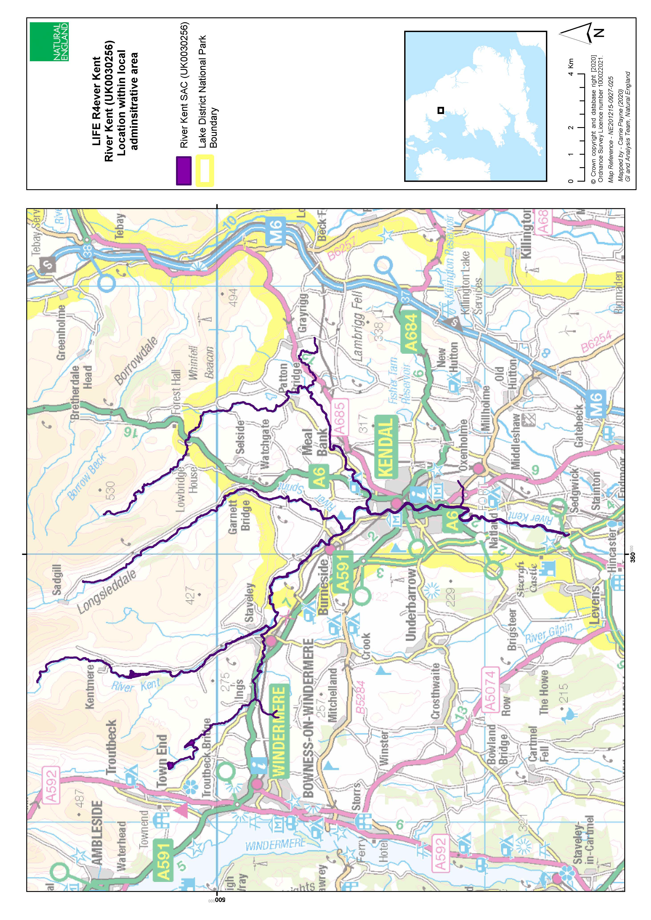
Figure 1. Map showing the River Kent & Tributaries Special Area of Conservation

2.3 Project Background
The River Kent and Tributaries is notified as a Site of Special Scientific Interest (SSSI) under the Wildlife and Countryside Act 1981, (as amended by The Countryside and Rights of Way Act 2000). One of the features for which the River Kent is notified as a SSSI is the native White-clawed crayfish, Austropotamobius pallipes. The site is also designated as a Special Area of Conservation (SAC) under the Conservation of Habitats and Species Regulations 2017 (as amended) in England and Wales. This designation also includes the species S1092 Freshwater crayfish, Austropotamobius pallipes.
Whilst previous survey work for white-clawed crayfish has been undertaken within the River Kent catchment, there has been no co-ordinated, catchment-wide, Common Standard Monitoring (CSM) compliant surveys to inform a SSSI condition assessment of this feature.
Natural England is therefore looking for a contractor to undertake an up-to-date CSM compliant assessment for the River Kent and Tributaries SSSI.
This population level assessment will be used by Natural England to undertake a Whole Feature Assessment of these monitored features, as well as a SSSI Unit condition assessment for the relevant units.
Existing population surveys will be made available on awarding of the contract.
General background information about the SSSI such as location, citation, views about management can be found here: SSSI detail (naturalengland.org.uk).
Site conservation objectives for the River Kent SAC: UK0030256_River Kent_SAC_Published 10 Jul 2024

2.4 Methods
The contractor shall consider each assessment unit separately, carrying out the detailed methodology for that unit as detailed in section 2.4.1, and produce a report for each assessment unit. These individual assessment reports will be incorporated into an overall report which itself summaries the overall findings.
The contractor shall select the locations for these surveys, aiming for a representative sample along the length of the river where white-clawed crayfish are known to occur within the River Kent and Tributaries SSSI. For information, the reaches of the River Kent where white-clawed crayfish are believed to occur are:
Unit Code | Unit Name
101 | Dubbs Reservoir
102 | Dubbs Beck
103 | Borrans Reservoir
104 | River Gowan
107 | River Kent in Kentmere
108 | Un-named tributary
109 | River Sprint
110 | River Mint
111 | Greyrigg Beck
112 | Gowan to Mint confluence
113 | River Kent in Kendal
114 | Natland Mill Beck
115 | River Kent downstream of Kendal
116 | Upper Kent in Kentmere and Kentmere Tarn

The assessment should include at least one assessment unit for each 10km of river habitat within each of the above SSSI Units. Each unit will consist of between 8-15 survey sites as per the relevant CSM guidance. See Figure 2.

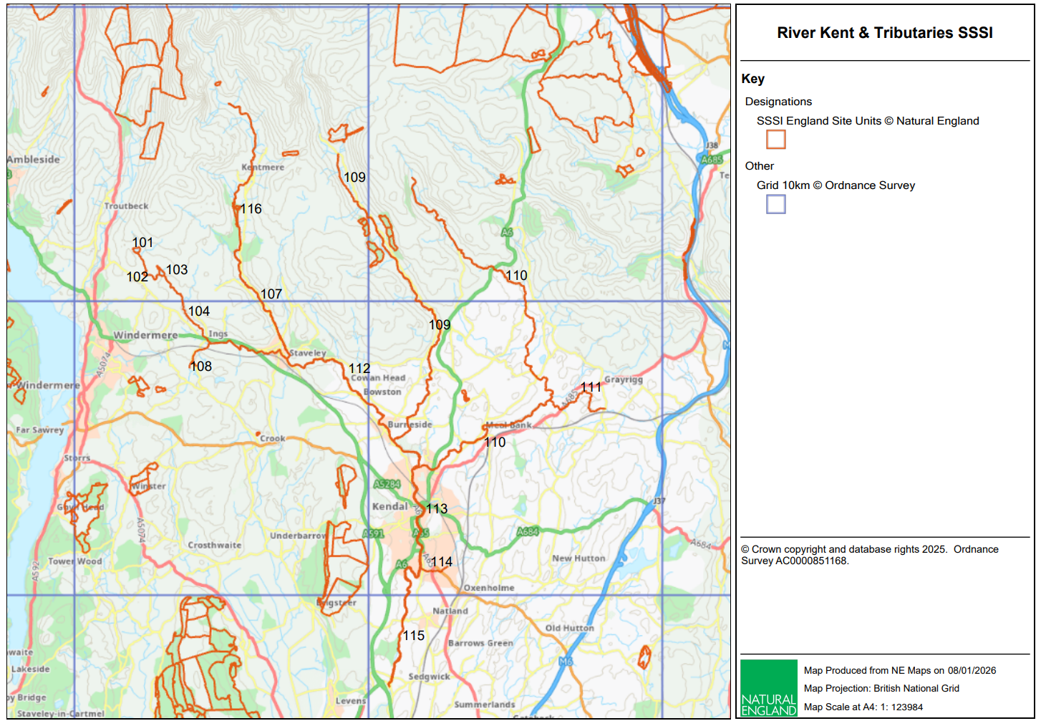
Figure 2. Map showing River Kent & Tributaries SSSI Units and 10km grid squares

2.4.1 Detailed Methodology
The contractor shall undertake monitoring of white-clawed crayfish (Austropotamobius pallipes) population in accordance with the Common Standards Monitoring Guidance for Freshwater Fauna (JNCC, October 2015). Surveys will be carried out between mid-July and late September 2026, the optimal period for crayfish monitoring following juvenile release and prior to the next breeding season.
Given the scale/number of samples required, and potential for factors (such as weather and river flows) to impact on available survey time, the contractor should propose an alternative timetable for surveying all these units/sites if this is not considered feasible in one year.
2.4.1.1 Survey Design and Site Selection
- Coverage: At least one assessment unit per 10 km of river habitat within each SSSI unit listed in Section 2.4 above.
- Sample Composition: Each assessment unit will comprise 8–15 survey sites, spaced ≥400 m apart, selected to represent the species’ natural range and habitat variability.
- Randomisation: Half of the sites will remain fixed across monitoring cycles; the remainder will be randomly selected to avoid bias. The contractor must provide a clear randomisation protocol.
2.4.1.2 Field Methods
- Primary Method: Manual searching is the standard approach. Baited trapping may be used only where manual search is impractical (e.g. unsuitable substrate or poor visibility).
- Effort: At each site, 100 refuges will be searched initially; if fewer than five crayfish are found, effort will increase to 250 refuges.
- Catch Per Unit Effort (CPUE): Record crayfish per 100 refuges (or per trap per night for trapping).
      - Attributes Recorded
  - Species, sex, and carapace length (CL) to 1 mm accuracy.
  - Juveniles (<25 mm CL) as evidence of recruitment.
  - Signs of disease (e.g. Thelohaniasis) and any moribund or dead specimens.
  - Presence of non-native crayfish species.
      - Environmental Data
Record habitat quality, refuge availability, siltation level, and pressures such as livestock access, gravel extraction, and vehicular disturbance using the standard habitat record card. This can be provided as presence/absence information for each area surveyed.

2.4.2 Reporting
Each assessment unit will be treated as a discrete data entry. The contractor will provide:
- A summary of spatial extent, abundance, age structure, population health, and pressures.
- Photographs illustrating habitat types and any observed pressures which could be negatively impacting on white-clawed crayfish.
- Recommendations for conservation actions to support the long-term viability of white-clawed crayfish populations.
  - Biosecurity
It is essential that the successful contractor provides a biosecurity management plan before the works commence. All personnel and equipment must comply with Check, Clean, Dry protocols. Aquatic biosecurity is of high importance on the River Kent to prevent the spread of invasive non-native species or disease: https://www.nonnativespecies.org/what-can-i-do/check-clean-dry/

2.6 Licensing and Consents
Natural England will provide landowner details for the contractor to arrange site access permissions.
Natural England will provide a data tracker for the consultant to record any third-party input data to the report.
Consultants will be responsible for organising and obtaining any other licenses and/or consents that may be required for the work.

2.7 Outputs
• A final report detailing the work undertaken, findings and interpretation of survey results as relating to a feature condition assessment status, including recommendations for any further investigations and monitoring required.
• The report and maps should be provided in Word and pdf formats.
• Supporting data may be provided as spreadsheets, with each assessment unit occupying its own sheet.
• Reports must all have the following standard cover wording: “LIFE R4ever Kent will restore and revitalise the River Kent SAC and its wider catchment, so it is more resilient to environmental pressures. Freshwater pearl mussel (FPM) (S1029) is a keystone species which requires clean gravel habitats and low suspended solids/nutrient loading. Improved water and habitat quality (including H3260 habitat) will benefit other aquatic/terrestrial species including the endangered White clawed crayfish (S1092) and provide optimum conditions for FPM's salmonid hosts. The project will trial new techniques, provide targeted advice and training and promote better replication/communication. Natural England (lead partner) is working in partnership with South Cumbrian Rivers Trust, Environment Agency and Freshwater Biological Association. The project is financially supported by LIFE, a financial instrument of the European Commission.”

2.8 Quote Format
Please provide a fixed price for the whole project costs, as well as itemised costs and expenses.
Costs should be broken down to show the time allocated to each part of the project. Please provide day rates, planned number of days and specify who will be carrying out the different aspects of the work. The schedule should include the work related to management of the project, the relationship between the contractor and the project partners and report production costs. Please detail any risks and assumptions made and exactly what has been included in the prices.
Please confirm that your prices will remain fixed and firm for the duration of the contract.
Please indicate if VAT will be applied.
Pricing Schedule Example:
Activity | Daily Rate excl. VAT | Number of Days | Total excl. VAT | Other Expenses
TOTALS excl. VAT
TOTALS incl. VAT

2.9 Timescales
Output | Completion date
Project set up meeting with NE | W/C 6 April 2026
Draft Report submitted to the Project Officer | 27 November 2026
Incorporate comments following discussion with Natural England and submit the final report. | 11 December 2026
Final report approved to the satisfaction of the Project Officer | 28 December 2026
Attend an in-person or virtual meeting to discuss the findings, recommendations and content of the draft report. | Date to be agreed with contractor, can be following approval of the final report
An invoice for the final payment following approval. | By 31 December 2027

It is anticipated that this contract will be awarded for a period of 10 months to end no later than 31/12/2026. Prices will remain fixed for the duration of the contract award period. We may at our sole discretion extend this contract to include related or further work. Any extension shall be agreed in advance of any work commencing and may be subject to further competition.

2.10 Knowledge and skills required
The lead consultant shall be an experienced ecologist and have substantial experience of white-clawed crayfish survey.
It is expected that all of the consultants or sub-contractors involved will have appropriate professional accreditation at a level commensurate with their role in the project.
The tender response should include:
- the project team structure
- a short profile/CV for each team member, indicating their relevant experience in projects of this nature and their professional accreditation and their role and responsibilities
- one example of similar previous work undertaken in the last three years for public or private sector clients.
- Health and Safety risk assessments, including working near water.
- Details of the biosecurity measures to be followed to prevent the spread of invasive non-native species and disease.

2.11 Electronic Data Supply
Where particular electronic formats are specified then these should be compatible with the respective application: Word; Excel; PowerPoint; ESRI ArcGIS.
Electronic data transfer should occur via email where possible, but where file size is excessive then this should be via memory stick. However, in both instances the sender should ensure the recipient has actually received the data.

2.12 Conditions for Data Collection
Physical and intellectual ownership of all field data generated as a result of this contract will become the physical and intellectual property of Natural England at the end point of this contract for use in any manner Natural England deems appropriate.
Contractors will need to agree to be bound by the following requirements:
“You agree to:
- grant to Natural England an irrevocable, perpetual and royalty-free licence to use, copy, keep and disseminate the Outputs as they see fit and to grant sub-licences of the same kind;
- obtain and maintain in force all authorisations of any kind required for you to use, copy, keep and disseminate the Outputs and to grant such licence to us;
- contract to the effect that any creation by you or on your behalf of material which forms Outputs is undertaken on terms that either the copyright in the material is assigned to you or that the copyright owner may not commercially exploit it;
- grant licences in respect of the Outputs under the Creative Commons model licence ‘Attribution Non-Commercial’ but not on other terms without our prior written consent;
- not otherwise exploit the Outputs commercially without our prior written consent from Natural England.”

Section 3: Contract Management and Evaluation
This contract shall be managed on behalf of the Authority by Morgan Barrie, morgan.barrie@naturalengland.org.uk
The contract will be managed by regular project update meetings, as well as interim telephone conversations as required (especially during the fieldwork stage).
Payment
The Authority will raise purchase orders to cover the cost of the services and will issue to the awarded supplier following contract award.
The Authority’s preference is for all invoices to be sent electronically, quoting a valid Purchase Order number. Invoices are to be submitted following completion of the final report (each year of the contract). You will be required to include the purchase order number, project name and reference number on all invoices (LIFE R4ever Kent LIFE20 NAT/UK/001013).
Evaluation Methodology
We will award this contract in line with the most economically advantageous tender (MEAT) as set out in the following award criteria:
Evaluation weightings are 50% technical and 50% commercial; the winning tenderer will be the highest scoring combined score.
Quality will be scored based on the opinion of the evaluating officers using the scoring criteria from the table below. The evaluating officer/s decision will be final.
Technical (50%)
Technical evaluations will be based on responses to specific questions covering key criteria which are outlined below. Scores for questions will be based on the following:
Criteria | Weighting | To include
Methodology | 50% | An outline of the proposed methods for surveying, recording and reporting.
Previous Experience | 25% | A description of previous similar projects which you have delivered including specific examples.
Technical knowledge & Staff experience | 25% | An overview of the staff who will be working on this project and their technical knowledge including resolving problems, knowledge of freshwater invertebrate ecology and WCC condition assessment surveying.

Scores for questions will be based on the following:
Description | Score | Definition
Very good | 100 | Addresses all the Authority’s requirements with all the relevant supporting information set out in the RFQ. There are no weaknesses and therefore the tender response gives the Authority complete confidence that all the requirements will be met to a high standard.
Good | 70 | Addresses all the Authority’s requirements with all the relevant supporting information set out in the RFQ. The response contains minor weaknesses and therefore the tender response gives the Authority confidence that all the requirements will be met to a good standard.
Moderate | 50 | Addresses most of the requirements with most of the relevant supporting information set out in the RFQ. The response contains moderate weaknesses and therefore the tender response gives the Authority confidence that most of the requirements will be met to a suitable standard.
Weak | 20 | Substantially addresses the requirements but not all and provides supporting information that is of limited or no relevance or a methodology containing significant weaknesses and therefore raises concerns for the Authority that the requirements may not all be met.
Unacceptable | 0 | No response or provides a response that gives the Authority no confidence that the requirement will be met.

Technical evaluation is assessed using the evaluation topics and sub-criteria stated in the Evaluation Criteria section above.
Separate submissions for each technical question should be provided and will be evaluated in isolation. Tenderers should provide answers that meet the criteria of each technical question.
Methodology | Detailed Evaluation Criteria
Q1.1 Provide details of the methodology and approaches proposed to deliver the requirements of this project.  Responses should not exceed six sides of A4, and use Arial font, size 11. | Your response should:  1) Demonstrate a clear understanding of the nature of the requirements, including CSM guidance compliance.  2) Include a practical, achievable, and cost-effective methodology covering site selection, randomisation, biosecurity, and risk management for adverse conditions.  3) Have information in sufficient detail to allow a full appraisal of the suitability of the approach to deliver for the project.

Previous Experience | Detailed Evaluation Criteria
Q2.1. Provide details of previous experience relevant to this project  Responses should not exceed six sides of A4, and use Arial font, size 11. | Your response should:  1) Include specific examples of similar projects, particularly CSM-compliant crayfish or freshwater invertebrate surveys.  2) Demonstrate successful delivery of projects with comparable scale and complexity.  3) Have information in sufficient detail to allow a full appraisal.

Technical Knowledge & Staff Experience | Detailed Evaluation Criteria
Q3.1 Provide details of the key staff to be used for the project  Responses should not exceed six sides of A4, and use Arial font, size 11. | Your response should:  1) Provide details of key staff, including qualifications, experience in crayfish monitoring, and relevant accreditations.  2) Explain contingency planning for staff changes and availability during survey season.  3) Have information in sufficient detail to allow a full appraisal.

Commercial (50%)
The Contract is to be awarded as a fixed price which will be paid according to the completion of the deliverables stated in the Specification of Requirements.
Suppliers are required to submit a total cost to provide the deliverables stated in the Specification of Requirements. In addition to this the Commercial Response template must be completed to provide a breakdown of the whole life costs against each deliverable used in the delivery of this requirement.
Calculation Method
The method for calculating the weighted scores is as follows:
- Commercial
Score = (Lowest Quotation Price / Supplier’s Quotation Price ) x 50% (Maximum available marks)
- Technical
Score = (Bidder’s Total Technical Score / Highest Technical Score) x 50% (Maximum available marks)
The total score (weighted) (TWS) is then calculated by adding the total weighted commercial score (WC) to the total weighted technical score (WT): WC + WT = TWS.

Information to be returned
Please note, the following information requested must be provided. Incomplete tender submissions may be discounted.
Please complete and return the following information:
- completed Commercial Response template
- separate response submission for each technical question (in accordance with the response instructions)
- complete AI question [ ''Do you use Artificial Intelligence (AI) or machine learning tools, including large language models within your quote submission or service delivery processes.?''] response which will not be scored, is to be returned within technical response
- completed Mandatory Requirements (Annex 1)
- completed Acceptance of Terms and Conditions (Annex 2)
Award
Once the evaluation of the Response(s) is complete all suppliers will be notified of the outcome via email. The successful supplier will be issued the contract, incorporating their Response, for signature. The Authority will then counter sign.

Annex 1 Mandatory Requirements
Part 1 Potential Supplier Information
Please answer the following self-declaration questions in full and include this Annex in your quotation response.
Part 1.1 Potential Supplier Information:
Question no. | Question | Response
1.1(a) | Full name of the potential supplier submitting the information
1.1(b) | Registered office address (if applicable)
1.1(c) | Company registration number (if applicable)
1.1(d) | Charity registration number (if applicable)
1.1(e) | Head office DUNS number (if applicable)
1.1(f) | Registered VAT number
1.1(g) | Are you a Small, Medium or Micro Enterprise (SME)? | (Yes / No)
Note: See EU definition of SME https://ec.europa.eu/growth/smes/business-friendly-environment/sme-definition_en
Part 1.2 Contact details and declaration
By submitting a quotation to this RFQ I declare that to the best of my knowledge the answers submitted and information contained in this document are correct and accurate.
I declare that, upon request and without delay you will provide the certificates or documentary evidence referred to in this document.
I understand that the information will be used in the selection process to assess my organisation’s suitability to be invited to participate further in this procurement.
I understand that the authority may reject this submission in its entirety if there is a failure to answer all the relevant questions fully, or if false/misleading information or content is provided in any section.
I am aware of the consequences of serious misrepresentation.

Question no. | Question | Response
1.2(a) | Contact name
1.2(b) | Name of organisation
1.2(c) | Role in organisation
1.2(d) | Phone number
1.2(e) | E-mail address
1.2(f) | Postal address
1.2(g) | Signature (electronic is acceptable)
1.2(h) | Date

Part 2 Exclusion Grounds
Part 2.1 Grounds for mandatory exclusion
Question no. | Question | Response
2.1(a) | Please indicate if, within the past five years you, your organisation or any other person who has powers of representation, decision or control in the organisation been convicted anywhere in the world of any of the offences within the summary below.
 | Participation in a criminal organisation. | (Yes / No)  If yes please provide details at 2.1 (b)
 | Corruption. | ((Yes / No)  If yes please provide details at 2.1 (b)
 | Fraud. | (Yes / No)  If yes please provide details at 2.1 (b)
 | Terrorist offences or offences linked to terrorist activities | (Yes / No)  If yes please provide details at 2.1 (b)
 | Money laundering or terrorist financing | (Yes / No)  If yes please provide details at 2.1 (b)
 | Child labour and other forms of trafficking in human beings | (Yes / No)  If yes please provide details at 2.1 (b)
2.1(b) | If you have answered yes to question 2.1(a), please provide further details.  Date of conviction, specify which of the grounds listed the conviction was for, and the reasons for conviction.  Identity of who has been convicted  If the relevant documentation is available electronically please provide the web address, issuing authority, precise reference of the documents.
2.1 (c) | If you have answered Yes to any of the points above have measures been taken to demonstrate the reliability of the organisation despite the existence of a relevant ground for exclusion? (i.e. Self-Cleaning) | (Yes / No)
2.1(d) | Has it been established, for your organisation by a judicial or administrative decision having final and binding effect in accordance with the legal provisions of any part of the United Kingdom or the legal provisions of the country in which the organisation is established (if outside the UK), that the organisation is in breach of obligations related to the payment of tax or social security contributions? | (Yes / No)
2.1(e) | If you have answered yes to question 2.3(a), please provide further details. Please also confirm you have paid or have entered into a binding arrangement with a view to paying, the outstanding sum including where applicable any accrued interest and/or fines.

Part 2.2 Grounds for discretionary exclusion
Question no. | Question | Response
2.2(a) | The detailed grounds for discretionary exclusion of an organisation are set out on this webpage, which should be referred to before completing these questions.  Please indicate if, within the past three years, anywhere in the world any of the following situations have applied to you, your organisation or any other person who has powers of representation, decision or control in the organisation
2.2(b) | Breach of environmental obligations? | (Yes / No)  If yes please provide details at 2.2 (f)
2.2(c) | Breach of social obligations? | (Yes / No)  If yes please provide details at 2.2 (f)
2.2(d) | Breach of labour law obligations? | (Yes / No)  If yes please provide details at 2.2 (f)
2.2(e) | Shown significant or persistent deficiencies in the performance of a substantive requirement under a prior public contract, a prior contract with a contracting entity, or a prior concession contract, which led to early termination of that prior contract, damages or other comparable sanctions? | (Yes / No)  If yes please provide details at 2.2 (f)
2.2 (f) | If you have answered Yes to any of the above, explain what measures been taken to demonstrate the reliability of the organisation despite the existence of a relevant ground for exclusion? (Self-Cleaning)

Annex 2 Acceptance of Terms and Conditions
I/We accept in full the terms and conditions appended to this Request for Quote document.
Company ____________________________________________________
Signature ____________________________________________________
Print Name ____________________________________________________
Position ____________________________________________________
Date ____________________________________________________

