Invitation to tender for works for Sevenoaks Town Council
1 - Supply and Installing 5 x Floodlighting Columns (reuse current LED Floodlights)
2 – Supply and Installing 1 x Floodlight Column and Floodlights.
At Raleys Field, Sevenoaks

Tenders are invited for the supply and installation of 5 Floodlighting Columns using current LED floodlights and a further 1 new column and floodlights at Raleys Field, off Plymouth Drive, Sevenoaks, Kent TN13 3RP.


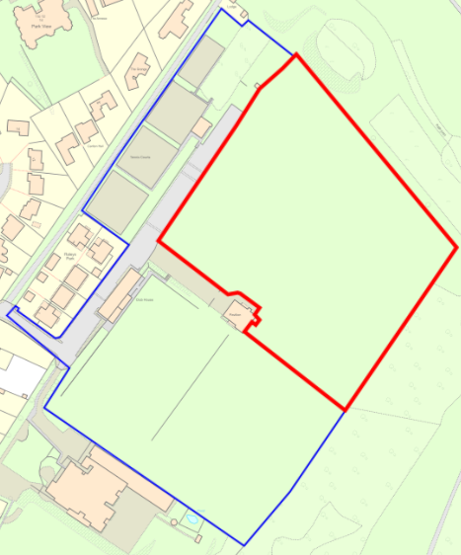
Plymouth Drive
Raleys Field
Tennis Courts
Knole Paddock

Background
Sevenoaks Town Council owns and operates the two above-pictured open public spaces referred to as Raleys Field (northern-most field) and Knole Paddock (southern field). These open spaces in addition to being used extensively by the general public are used for cricket, football and rugby.

Adjacent to the open space is the Sevenoaks Rugby Football Club and the fields are primarily used by them during the rugby season.

To the best of the Town Council’s knowledge the current floodlighting columns were installed over 30 years ago originally the responsibility of the Rugby club who had paid for; and maintained the floodlights and floodlight columns. In 2022 it was considered that the old sodium lights had reached the end of their life, the Rugby Club were not in a position to address this which instigated Sevenoaks Town Council taking on the replacement with brighter low energy LED lights on the existing columns.

In replacing the bulbs for the rugby season this year one of the mechanism for lowering the floodlights failed. This has brought into question the structural integrity of the old floodlights.

The rugby pitches have static floodlights on one side. The other side has portable floodlights as permanent cannot be installed as this would impact the cricket pitches.

Key Points

- The tender is for replacement 5 columns for current floodlights

- Separately for 1 further new column (new electrics etc) and floodlight.

- To be installed outside of rugby playing season.

- Columns to be able to be lowered to enable change of bulbs etc.

- Demonstration of meeting all compliant standards e.g. electrics, H&S.

- Location of Current Floodlighting Columns:
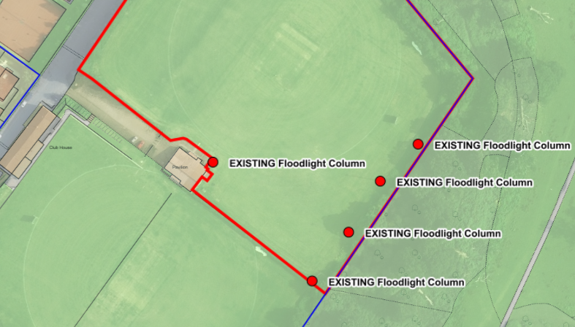

- Location for new Floodlighting Column – See Map 2 below
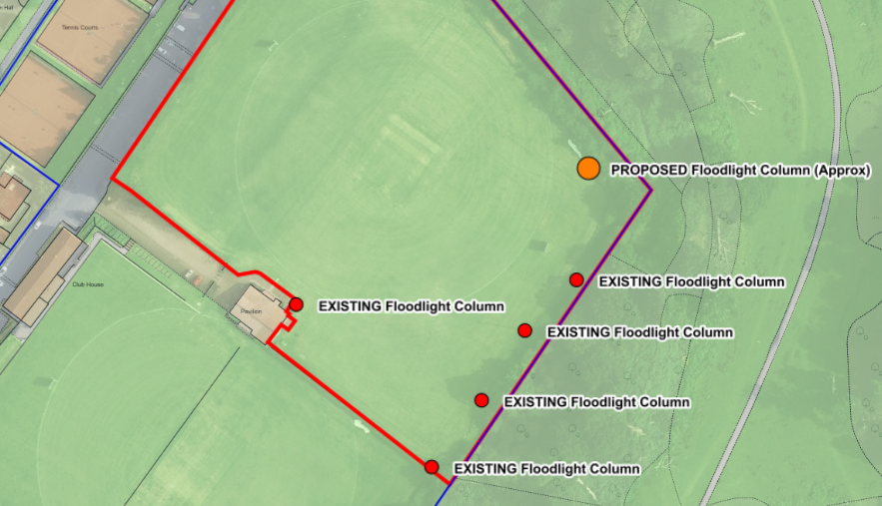
- A site visit is advised in preparation of your tender to assess access etc.

General Scope of Contract
- Ownership, liability and responsibility for insurance of the works and associated equipment will remain with the contractor until satisfactory reports have been accepted by Sevenoaks Town Council.

- A project coordinator or single point of contact must be provided by the successful tenderer who will remain contactable to deal with any queries or problems that may arise. The point of contact must be available from the date the contract is awarded until satisfactory completion of the project.

- The contractor will be required to liaise closely with Sevenoaks Town Council prior to commencement of works and during the installation period.

- Whilst construction is taking place, the area must be contained within security fencing to prevent unauthorised access. Fencing to be provided at contractor’s cost.

- Storage of machinery, equipment and materials will be the responsibility of the contractor.

- All excess materials and spoil from excavation are to be disposed of at the contractors cost at a licensed recycling centre.

- Any area of the recreation ground or private property damaged by the contractor during the works must be reinstated to its original condition at the contractors cost.
Specification to include:
- All professional fees and design
- Drawings of proposed design
- Mobilisation and set
- Setting out of work area
- Installation
- Demobilisation and any reinstatements

Health and Safety Requirements
Tenderers will be required to supply Sevenoaks Town Council with copies of the following with the tender submission:

- Method statements
- General Risk Assessments
- Health and Safety Policy
- Certificate of Public Liability Insurance
- Certificate of Employers Liability Insurance
- Proof of Operative Qualifications.

Guarantees and Warranties
Please provide a detailed breakdown of warrantees and guarantees for all items to be installed.

Evaluation and Awarding of the Contract
The contract will be awarded to the company that complies with all written requirements, has satisfactory references, offers best value of service and price. Guarantees and warranties will be assessed on their own merit to ensure ongoing maintenance is kept to a minimum. Sevenoaks Town Council may require further information from the tenderer after the submission deadline, if this occurs, we will contact the contractors nominate person named in the tender questionnaire.

The contract will be evaluated on the following basis:

Complete written tender
Trade references
Additional facilities – fencing, safety surface
Price
Feedback from Public
Maintenance requirements

Thank you for your interest in tendering for the new Greatness Recreation Ground Play Area.

Linda Larter

Linda Larter MBE
Chief Executive
Sevenoaks Town Council

