Invitation to Tender
Submission Instructions
Deadline for tender submission 22nd February 2026
To submit tenders via email to admin@willitonpc.org.uk
Any queries to admin@willitonpc.org.uk
01984 633979
Procurement timetable
Award Decision 2nd March 2026
Work to start by 23rd March 2026
Conditions of Participation
1. Mandatory Legal & Financial Compliance
These are "Pass/Fail" requirements that a supplier must meet before their quote is even considered.
- Insurance Coverage: Suppliers must typically provide evidence of:
  - Public Liability Insurance: Minimum of £10 million.
  - Employers' Liability Insurance: Minimum of £10 million.
  - Professional Indemnity Insurance: Minimum of £5 million for design-and-build projects.
- Financial Capacity: Evidence of stable financial standing i.e. two years of audited accounts.
- Waste Management: confirmation of your Waste Carriers License for the legal disposal of old equipment and spoil if needed.
- Reference: two references from similar local authority projects completed in the last three years.
2. Technical Ability & Safety Standards
Suppliers must demonstrate they can execute the work to current 2026 industry benchmarks.
- Equipment Compliance: All equipment must be certified to BS EN 1176 (the European and British standard for playground equipment).
- Surfacing Compliance: Impact-absorbing surfacing must meet BS EN 1177 standards, ensuring it is appropriate for the "Critical Fall Height" of the equipment.

Technical Specifications and Scope
Brief
An item of play equipment/items of play equipment with metal based frame in the style of Ninja Play/trim trail/Tough Trail that holds a more physical type of play aimed at the older children but would still hold play value for the younger children with parental/guardian supervision and also a metal framed inclusive swing.
Location of Play items:
Location of the play area – Williton War Memorial Recreation Ground, Robert Street, Williton, Somerset, TA4 4PG
Site Plan
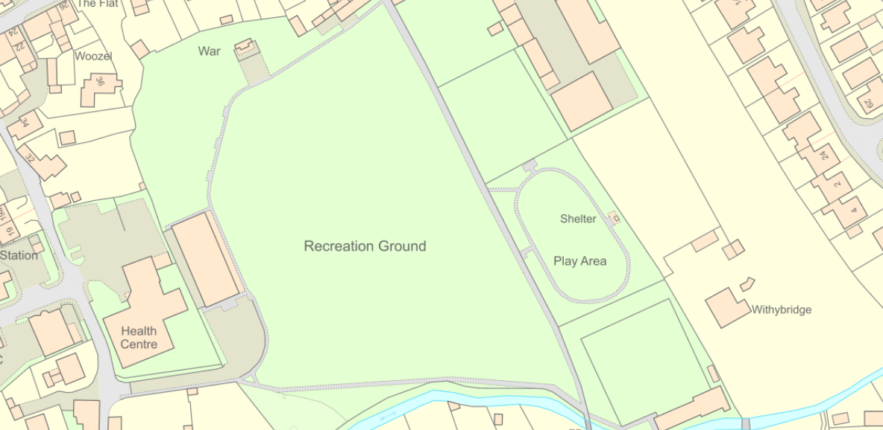

Location of new play unit/equipment

Location of inclusive swing
To note that access to the play area is via Robert Street and over the Recreation Ground (soft ground no hard ground access to play area)

Standards: Mandatory compliance with BS EN 1176 and BS EN 1177.
3. Response Templates
- Form of Tender: Williton Parish Council would like a signed declaration confirming the supplier's price and agreement to the terms.
- Pricing Schedule: A broken-down table for equipment, surfacing, installation.
- Design Proposal Requirements: please provide visuals and a list of all equipment with technical data sheets.
4. Terms and Conditions (The Contract)
- Risk assessment to be carried out and submitted.
- Warranties: confirmation of your guarantee periods for parts and labour.
- Payment Terms: Standard 30 day payment.
5. Supplier Due Diligence Forms
- Financial & Legal Standing: Confirmation that the company are not on the national Debarment List and have up-to-date information on the Central Digital Platform.
- References: At least two references from similar local authority projects completed in the last three years.

