Tender Notice for
The Provision of DSP Phase 2

Issue Date: 22/01/2026
Closing Date and Time: 17/02/2026

NGN Primary Contact: Elle Flood
eflood@northerngas.co.uk

NGN Secondary Contact: Joanna Palmer
jpalmer@northerngas.co.uk

Contents
Guidance. Please read carefully on how to proceed with event 3
Introduction…………………………………. 4
Northern Gas Networks Geographic Area 5
NGN Core Values 5
Scope of Requirements 6

Guidance
This Tender Notice is issued by Northern Gas Networks (NGN) and is live until 17/02/2026 at 5pm.
The aim of this Tender Notice is to:

* Ensure we provide bidders with adequate information to determine if they wish to proceed with this tender event.

* Provide NGN with a more detailed understanding of the interest within the market.

The Tender Notice process is the first stage of multistage procurement process.
All interested suppliers must follow the below steps in order to proceed with the conditions of participation and PQQ stages of this procurement event:

Sign up or Sign in to NGNs Tendering Portal – Market Dojo. Follow this link to do so: sign-up - Market Dojo

When you have logged in to your dashboard, you'll need to click the 'Show all or enter invite code' button under the Event Invitations section, as per below screenshot:
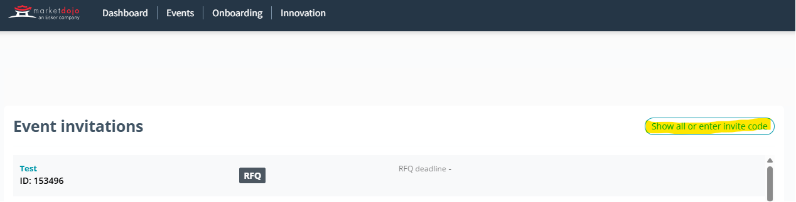

You’ll need to enter this code: FFE95DA355

It will then notify NGN to approve you onto the tender event. Once approved you will be given access to the event, where you’ll be taken to the Conditions of Participation stage, this stage is a pass/fail and will be locked until after the PQQ submission deadline. Any supplier who fails this stage will automatically be withdrawn from the process and will not gain access to the PQQ. All suppliers who pass this stage will be automatically taken to the PQQ where they will be given a deadline and detail to complete.

Once the PQQ has been evaluated by NGNs internal evaluation team all those who meet the criteria will be sent to the RFP stage where NGN will assess against award criteria.

Introduction

Northern Gas Networks Limited (NGN) is the company responsible for distributing gas to homes and businesses across the North of England. As part of the restructuring of the gas distribution business in England, NGN successfully acquired the North of England gas Distribution Network (DN) and took control of the assets on 1st June 2005. NGN has been responsible since then for the transportation of gas to the North of England via 36,000Km of pipelines.

The DN is located in the North of England and extends south from the Scottish border to South Yorkshire and has coastlines on both the East and West sides of the region. The DN contains a mixture of large cities such as Newcastle, Middlesbrough, Leeds and Bradford and a significant rural area including North Yorkshire and Cumbria. The area covers around 6.7 million inhabitants and has approximately 2.5 million customers. The DN is supplied via 23 off takes from the national Transmission System.

Northern Gas Networks Geographic Area

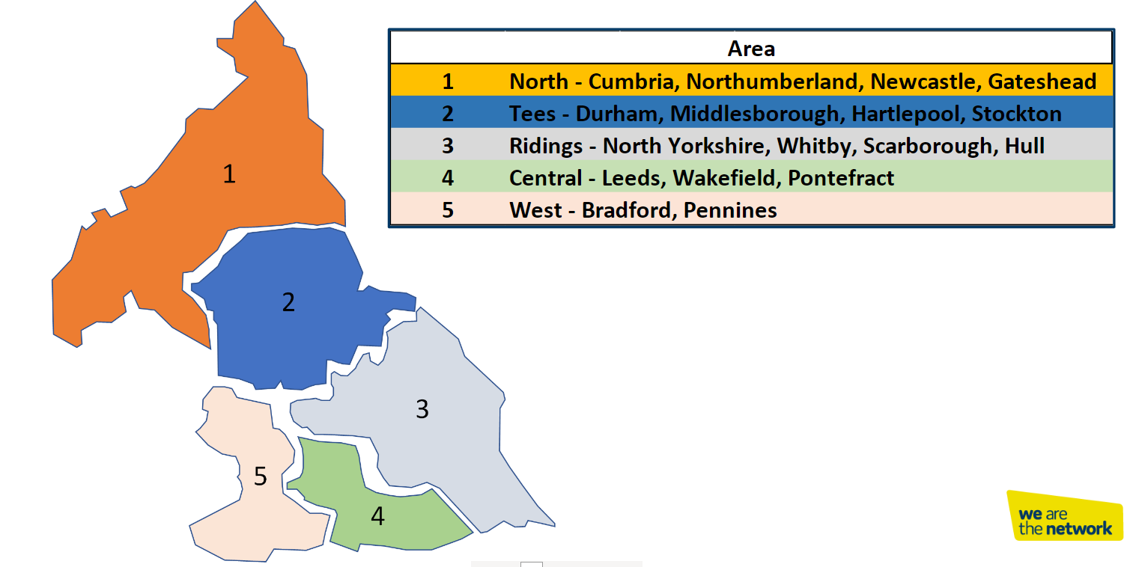

NGN Core Values

NGNs dream is to become the UK’s most loved, admired and respected company, and to establish a reputation for doing business really well through a united and empowered team that is mind-blowingly great. We recognise the important role that our supply chain partners having in supporting NGN to achieve our dream.

Our dream lies at​​ the centre everything we do and has been translated into a unique set of values that reflect and reinforce our culture.
- Trailblazing
- Intellectually Curious
- Community Focused
- Empowered
- Heartfelt
- Happy

Every member of our team is passionate about the contribution they make to our growing reputation as a pioneering, effective, conscious and enlightened business that is focused on changing the way that things are done.

We expect our suppliers to share our vision and values and our way to support NGN in achieving our goals.

Scope of Requirements

Northern Gas Networks (NGN) is initiating a Phase 2 procurement event to expand the existing Direct Service Provider (DSP) Framework, which currently runs until 2029 with options to extend. Due to capacity constraints within the current framework, additional suppliers are required to ensure sufficient resource availability across the network. This expansion is intended to supplement—not replace—the existing DSP supply.

The scope of the framework agreement includes but is not limited to for both natural gas and hydrogen;

Essential Scope Requirement

- All mains and services replacement, abandonment, general and specific reinforcement, diversionary and connections works.
- All mains work comprises of laying, relaying of Polyethylene (PE) and steel mains up to 48”/1200mm diameter which are laid and tested to main laying standards, and any service up to 63mm diameter and any associated abandonment.
- Service works comprises of the installation of new, or renewal and transfer of existing PE services up to 63mm diameter and Steel services up to 2” diameter.
- Riser works comprises of the installation of new, or the renewal and transfer of existing PE risers up to 32mm diameter and steel risers up to 3” diameter.
- Survey/Enabling works.
- Low pressure connections & disconnections (e.g. PE, Steel etc.).
- Medium pressure connections & disconnections (e.g. PE, Steel etc.).
- Intermediate pressure connections& disconnections (e.g. HDPE, Steel etc.).
- New services on mains in existing properties.
- Survey/enabling works includes invasive and non-invasive enabling works e.g. trial holes and camera survey.
- Backfill & reinstatement of all works, public & private.
- Support to NGN works on a planned and emergency basis for incidents e.g. severe weather, customer loss of supply and other emergency/non-emergency support, as and when required.
- Provide engineers/teams to support NGN in Gas Emergency & Repair Works.

Scope Requirement (Desirable)

- Gas safety regulation cut offs.
- Stub ends works.
- Bulk service renewal.
- Live service insertion.
- Service extraction.
- Replacement of risers, laterals and supplies to multi occupancy buildings.
- Refurbishment techniques for mains and services.
- Services off mains in private (New Service/New Property).
- New services on mains in existing property.
- Bridge overcrossings.
- Provide support to NGN in backfill & reinstatement works, as and when required.
- Gas appliance purge & relight, as and when required during incident support.
- Fuel poverty projects.
- District governor installation & removal including foundations/concrete base.
- Specialist flow stopping techniques.
- Deep excavations installation & removal

In additional please see the Draft Contract contained with this Tender package for full Works Information

Technical Standards and Procedures –

All works MUST be carried out in compliance with Northern Gas Networks Technical Standards and in line with Northern Gas Networks Procedures.

