Invitation to tender for works for Sevenoaks Town Council
Designing and Installing an Infant /Junior Play Area
At Greatness Recreation Ground, Sevenoaks

Tenders are invited for the design and installation of an infant / junior play area at Greatness Recreation Ground, Mill Lane, Sevenoaks, Kent TN14 5BX

Location Map is below
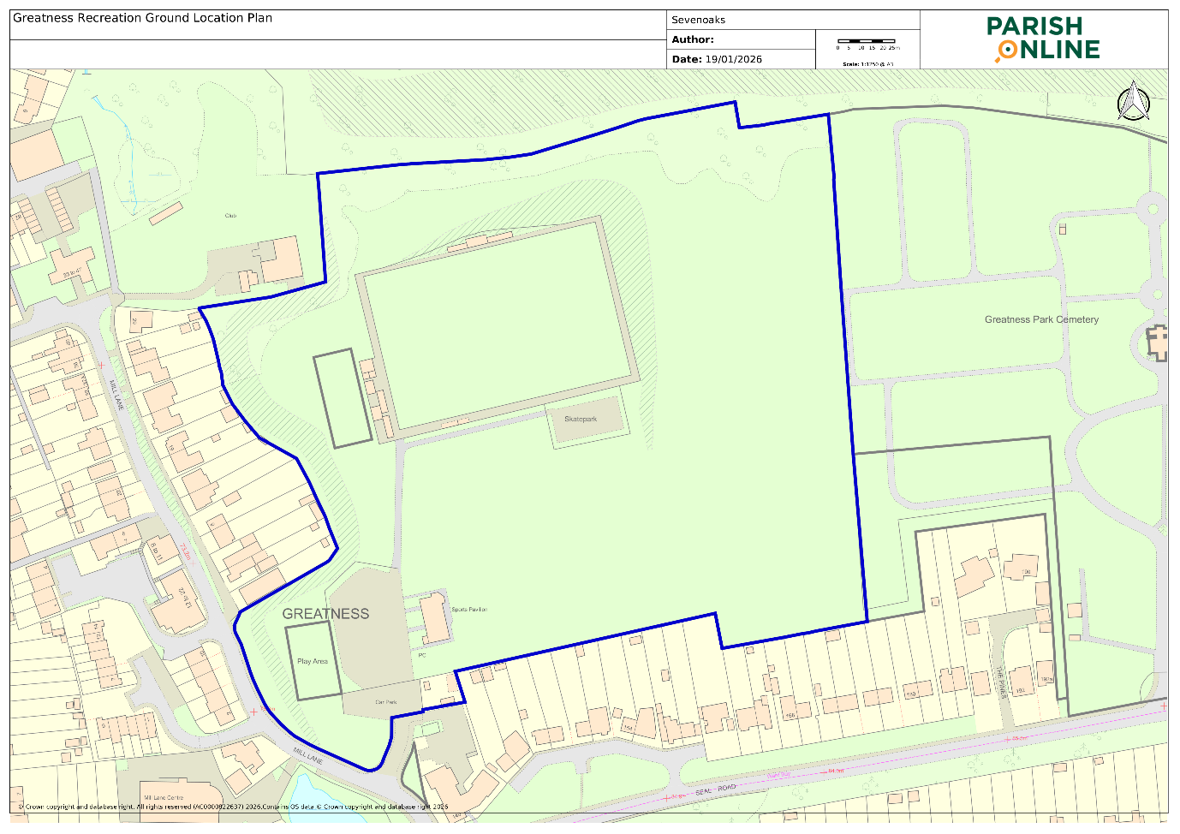

Background
Greatness Recreation Ground has become more and more popular as a local open space facility. It is developing from an original open space recreation ground into a more formal park. This is likely to only increase with a neighbouring development of approximately 900 dwellings to be started within the next five years.

It is also the home of the very successful Sevenoaks Town Football Club, which brings many visitors to the park. During 2026 the football club’s new pavilion is due to be completed.

Bearing in mind all these changes Sevenoaks Town Council carried out a community survey relating to the future of the open space and its facilities.

From the responses it was clear that the current play area which has been in place for fifteen years needed to be reviewed and upgraded. Following consultation, it was also agreed to move its location to enable families who were already on the grass area to have a child use the play area without crossing the car park. The proposed new location would also be nearer the new pavilion which will have toilets and a café.

Key Points

- The tender is for a completely new playground on a field.
Therefore, infrastructure e.g. drainage, fencing, safety surface, entry gates required.

- Aimed at primary school children

- Natural look equipment rather than bright colours, meeting ROSPA standards

- Requires some DDA compliant inclusive play equipment

- Requires some shading (preferably natural e.g. trees). Must retain the existing tree, ideally within the proposed footprint, or otherwise just outside of it)

- To create a wetpour base with a new wetpour safety surface which compiles with BSEN 1176 and has a minimum guarantee of 2 years but preferably longer. A maintenance plan is a desirable extra service we would like. The product should have been tested in accordance with BS EN 1177 and BS EN 7188.

- Timetable

- May 2026 public consultation on preferred options
A1 size image of play area to be provided.
- July 2026 appointment of contractor
- October 2026 installation

- Size of play area
Existing: Approx 32.7m length x 19.5m width
New: 41.5m length x 17m width

- Location of Play Area
Plan 1: Proposed placement in relation to existing location and surrounding site:
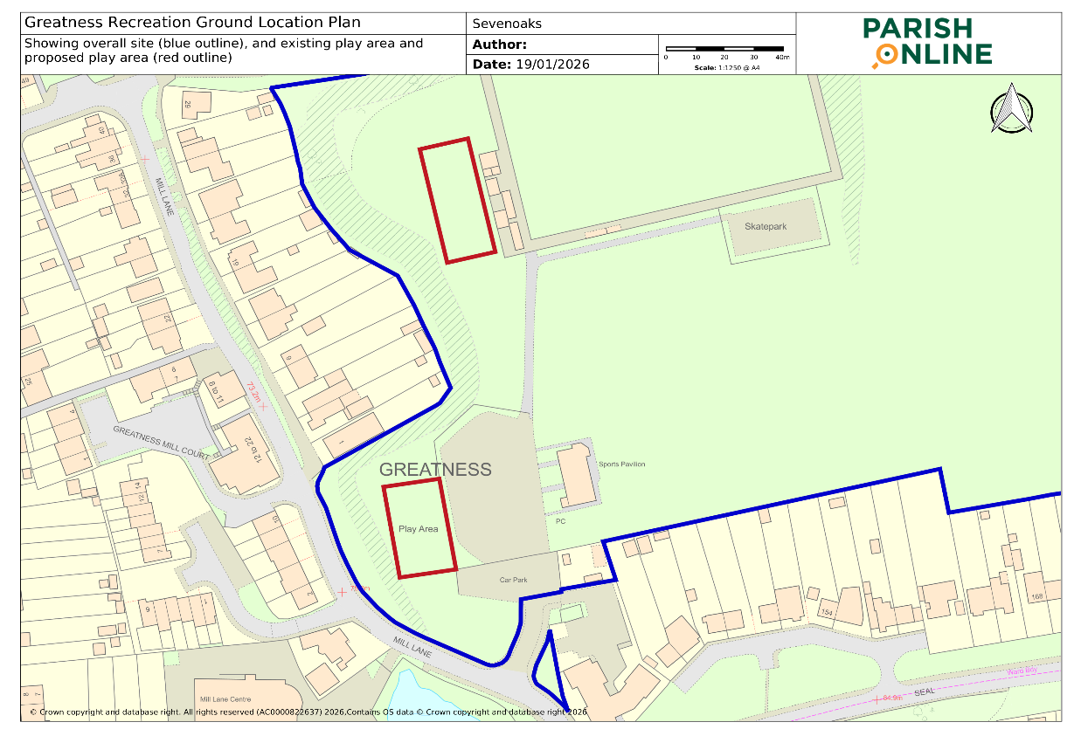
EXISTING
PROPOSED
Plan 2: Proposed placement in relation to trees and adjacent structures. Designs must retain existing trees and would ideally incorporate the below tree either within or just outside of the play area boundary, to create natural shading. Informal walking access will be required between the play area and its surrounding structures on both sides (~2.5m each side).
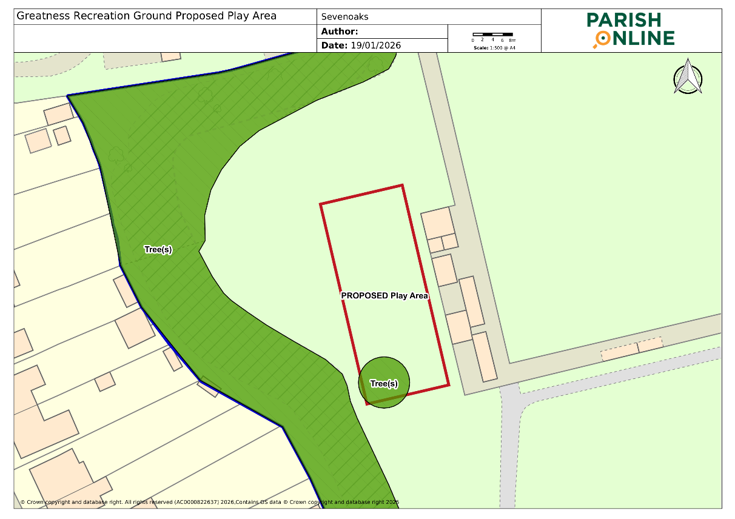
Plan 3: Initial designs for the play area’s relocation, as part of an associated new football pavilion project for the wider site:
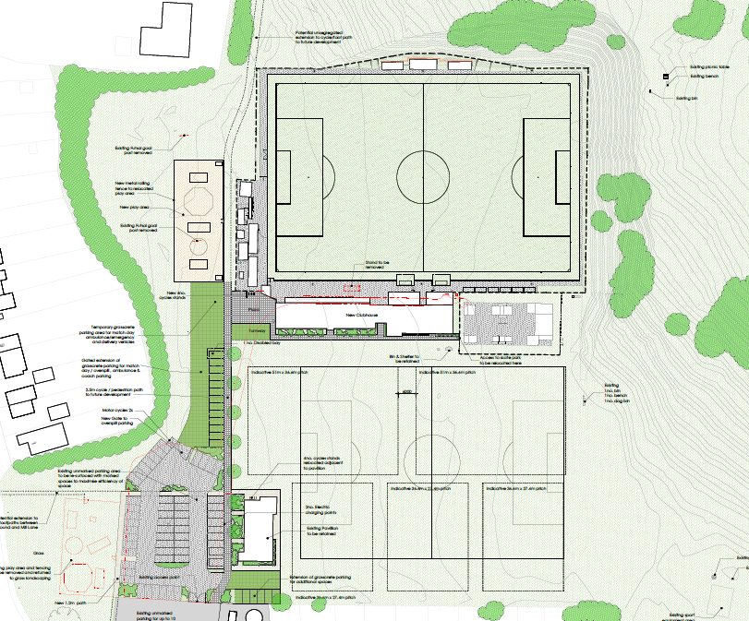

- Only tenderers with a current API (Association of Play Industries) membership will be considered for the project.

- A site visit is advised in preparation of your tender to assess access etc.
Budget for the Project
Maximum budget for the play area project is £200,000.

General Scope of Contract
- Ownership, liability and responsibility for insurance of the play area and associated equipment will remain with the contractor until satisfactory reports have been accepted by Sevenoaks Town Council. This will include a RoSPA report.
- A project coordinator or single point of contact must be provided by the successful tenderer who will remain contactable to deal with any queries or problems that may arise. The point of contact must be available from the date the contract is awarded until satisfactory completion of the project.

- The contractor will be required to liaise closely with Sevenoaks Town Council prior to commencement of works and during the installation period.
- Whilst construction is taking place, the area must be contained within security fencing to prevent unauthorised access. Fencing to be provided at contractor’s cost.

- Storage of machinery, equipment and materials will be the responsibility of the contractor.

- All excess materials and spoil from excavation are to be disposed of at the contractors cost at a licensed recycling centre.

- Any area of the recreation ground or private property damaged by the contractor during the works must be reinstated to its original condition at the contractors cost.

Specification to include:
- All professional fees and design
- Drawings of proposed design – including A1 Presentation Board
- Mobilisation and set
- Setting out of work area
- Installation
- RoSPA post installation report
- Demobilisation and any reinstatements

Items to Note
- No tunnels or roofs
- Equipment must be robust, vandal resistant with tamperproof fixings
- If panelling to be included, these must be easy clean
- Equipment will be predominantly constructed from metal
- Play equipment to be targeted at age ranges up to 10 years
- Accessible equipment to be included.

Health and Safety Requirements
Tenderers will be required to supply Sevenoaks Town Council with copies of the following with the tender submission:

- Method statements
- General Risk Assessments
- Health and Safety Policy
- Certificate of Public Liability Insurance
- Certificate of Employers Liability Insurance
- Proof of Operative Qualifications.

Guarantees and Warranties
Please provide a detailed breakdown of warrantees and guarantees for all items to be installed including:

- Wet pour surfacing
- Fencing
- All Play Equipment

Evaluation and Awarding of the Contract
The contract will be awarded to the company that complies with all written requirements, has satisfactory references, offers best value of service and price. Feedback from the public consultation will also be taken into account. Guarantees and warranties will be assessed on their own merit to ensure ongoing maintenance is kept to a minimum. Sevenoaks Town Council may require further information from the tenderer after the submission deadline, if this occurs, we will contact the contractors nominate person named in the tender questionnaire.

The contract will be evaluated on the following basis:

Complete written tender
Trade references
Best Value / Equipment for Play Area
Inclusive play elements
Additional facilities – fencing, safety surface
Price
Feedback from Public
Maintenance requirements

Thank you for your interest in tendering for the new Greatness Recreation Ground Play Area.

Linda Larter

Linda Larter MBE
Chief Executive
Sevenoaks Town Council

