**Appendix 3: Scope of Works and Specification**

1. **Site identification**

|  |  |  |  |
| --- | --- | --- | --- |
| **Site name** | Oakwood Park Play Area | | |
| **Site address** | Ash Close, Faringdon | **Site Postcode** | SN7 8EJ |
| **What3Words location** | ///shadowed.dynamics.summer | | |

Site photograph/s:

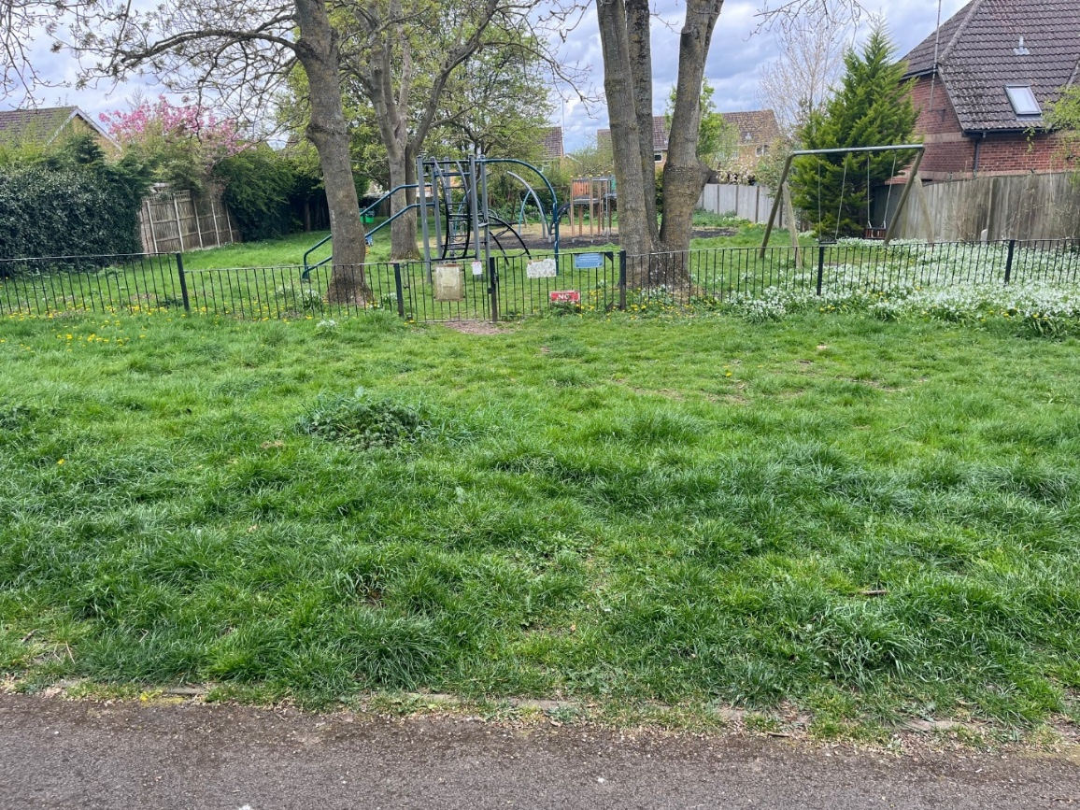

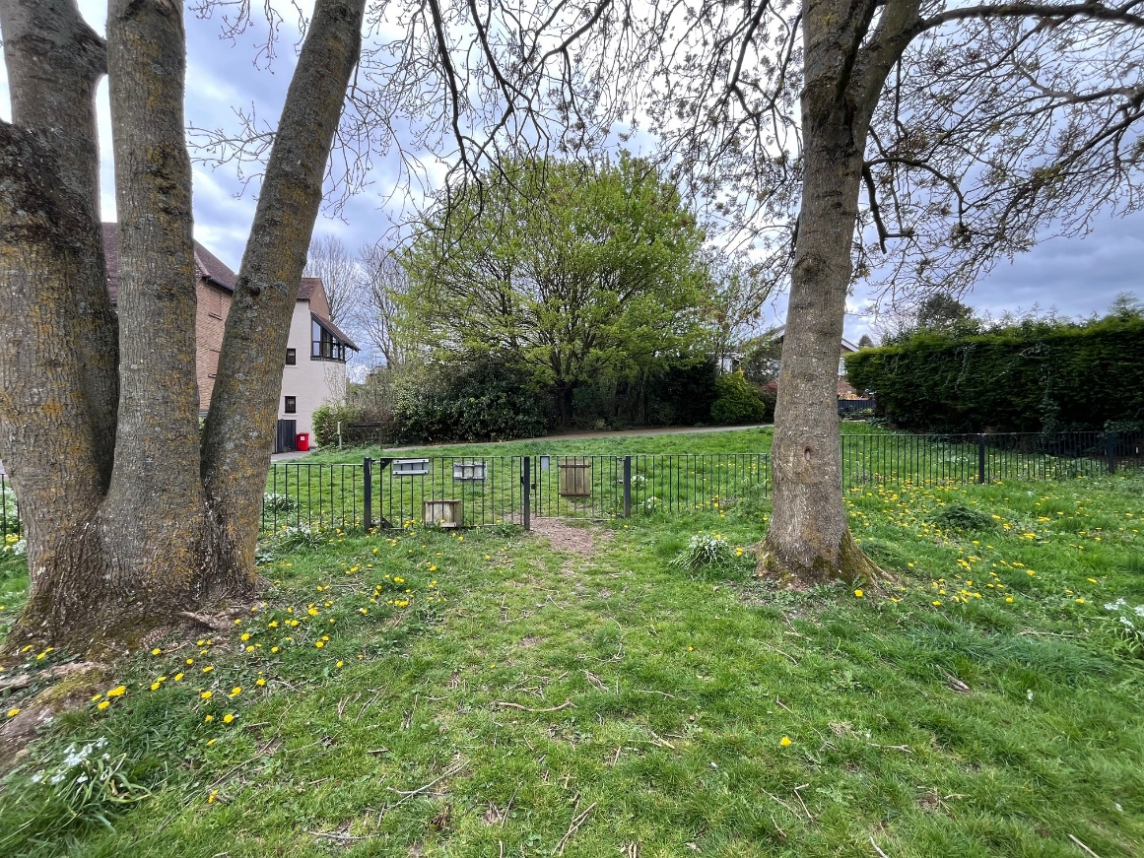

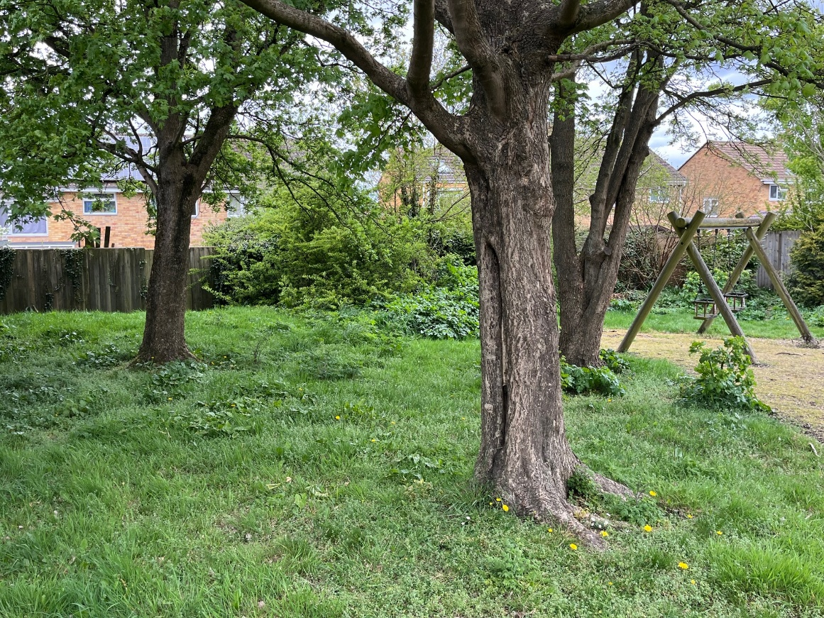

Google Map and Proposed Plan:

**Yellow Line:** Site Boundary

**Red Line:** Proposed Equipment Location

**Green Line:** Proposed Pathway

**Blue Line:** New Play Fence Line and Gate

Site set-up:

Welfare (drinking water and a portable toilet) must be provided for the duration of the Works.

Heras Fencing must be established around the entire site for the duration of the Works, with sufficient CDM signage and double clipped.

Compound and Access Route: details on the tender submission should include any vehicle access route and contractor parking, proposed compound, and processes to mitigate any impact on the community such as vehicle movement, noise, or any other factors. This should be in the form of a concise or simplified construction plan (maximum 1 page) to evidence some thought has been considered to the site in terms of delivering the project.

1. **Lot budget**

The proposed budget is **£100,000.00 (Ex VAT).**

The full budget should be used but not exceeded.

All features included within the design must be included within the budget and quotation, there must be no ‘suggested’ additional works shown in the design outside the tendered price.

1. **Site requirements & objective**

The current play area suffers from various issues, both naturally occurring and the current equipment, surfacing and general design. The Council would like to see a design that not only considers the site challenges but potentially utilises the natural features and ultimately make it a desirable place to visit. Ultimately, it needs to be practical in terms of access and seating, with a sensible design in terms of the how trees and wildlife may impact the use and general maintenance and be sensitive to the location and neighbours.

**Note:** It is important to note that the site has large trees with wide canopies, mainly near the entrance with several bird nests. As a result, the area suffers from high amounts of bird droppings, therefore positioning of new equipment and seating needs careful consideration to ensure this is mitigated. Suppliers should also ensure that the design allows for the trees in terms of the root system (root protection and potential damage they may cause), debris and any impact on the proposed surfacing.

The objective is to provide easily accessible play opportunities within a relatively confined space, while being considerate of the neighbours including height of equipment and potential noise. The new pathway should improve access to seating and equipment, while the overall design should complement the existing natural features of the site.

1. **Specification** 
   1. Play equipment

Play equipment construction should be predominately **steel** or a similar robust materialwith muted colours/panels such as greens and browns. Additional materials are acceptable for non-structural parts. Timber junior equipment is not acceptable for this site.

Fixings should be anti-tamper style (Torx Screws), and any bolts covered with protective caps.

Chains should be stainless steel.

Rope should have a steel core.

Slides must be stainless steel.

Swings should have Anti-Wrap connectors where possible.

Siting of the equipment should be away from the tree canopies where possible, as indicated on the Google Map (Red Line).

Maximum height for equipment: 4.0 metres (however should not exceed the current highest piece of equipment where practical to do so).

* 1. Safety Surfacing

Surfacing may be a combination of rubber wetpour and grass-matts. It is envisaged that items for young children (toddlers) and high wear items (such as swings) are located on wetpour (away from the trees to avoid moss and debris). Items mainly used by older children or in location likely to be impacted by trees may have grass mats.

Grass mats shall be fire retardant, cable tied, and have turf provided under where grass is not established. Also requires the installation of *Grass Mat Underlay Mesh.*

Wetpour sub-base works shall be excavated to the depth required for a flush finish with the surrounding area, back filled with 100mm depth of compacted MOT Type 1 stone laid beneath the rubber surface.

Edges should be trench cut into the surrounding grass or fully resin bonded to the pre-cast concrete (PCC) edging if adjoining a pathway.

Black wetpour shall have a minimum **50% colour fleck** (muted colour options such as green, brown or sand) at this location.

* 1. Pathways

A new pathway must be included from the existing tarmac footpath to provide a high level of accessibility for all throughout the year and in all weather conditions. Pathways must be a minimum 1.2 metres wide. Footpath widths should be clearly noted on your design plan.

Pathways should be constructed from a rubber/stone/ resin mix (such as ‘Conipave’/ ‘Enviro-Pave’ or similar). Pathway edging shall be pre-cast concrete (PCC).

* 1. Fencing & Gates

Fencing is required to replace the existing black fence line (approx. 25 liner metres) including new gates). Fencing shall be steel bow-top style railings compliant with EN1176, 1.0m high, powder coated in dark green.

Gate (1) shall be hydraulic (not sprung) self-closing with a flat top style, vertical bar in fill and powder coated in yellow to visually contrast from the fencing. A vehicle access gate (maintenance gate) must also be provided located in an appropriate position for access by mowing vehicles. This may be a dedicated vehicle access gate or a combination gate and located in an appropriate position for access by mowing vehicles.

* 1. Landscaping and Planting

Include some areas of wildflower, meadow style planting space in and around the three large trees towards the front of the site. This may require some landscaping with some stepping stones or design to help utilise the space.

* 1. Furniture

Seating should be: 3 x Glasdon ‘Pheonix’ seats with armrests.

All seating must be on hardstanding and connected to new pathways.

Circular or hexagonal benches around the tree trucks x 2. These should be made of a durable material, such as recycled plastic and installation should be considerate of root systems and ensuring there is no risk to the health of the trees.

Litter bin should be: 1 x Broxap ‘Derby’ Steel, 120 Litres in Black located near the pedestrian gate on hardstanding.

* 1. Removals

All play steel fencing, surfacing, seating, hardstanding and equipment is to be removed and disposed of in a suitably licenced facility. All spoil and waste are also to be removed and disposed of accordingly. Any foundations or materials from existing equipment that remains, such as those at or under ground level, must not impede or create any potential risk to persons or quality issues to the new surfacing and equipment.

* 1. Re-Instatement

All damage resulting from removals, vehicle movement, installation, deliveries or any other aspect of the Works, must be repaired to at least the condition of that item or items or replaced with the same or similar alternative/s. This includes any ground repair, that either needs soil, grading and grass seed for minor damage, or new turf for any major damage.

* 1. Post Installation Inspection

A post installation inspection by an independent RPii qualified inspector (i.e. Play Inspection Company, RoSPA or other similar provider) is required to sign off the completed installation. The contractor should allow for this cost within their tender price.

* 1. Play Sign

Signage x 1 (minimum A2 size) on steel posts should be provided to indicate: The site name, age the play area is intended for use by, telephone number to report any incident or damage, number to call in an emergency, Town Council logo.

Include graphics that demonstrate:

* children to be accompanied by adults
* dogs are excluded
* smoking is prohibited
* litter should be disposed of

4.10 Summary of Requirements

Below is a table of the all the requirements set out in this document, which each supplier must complete their response and any further detail to each point:

|  |  |  |  |
| --- | --- | --- | --- |
| **Item** | **Requested Specification** | **Supplier Response** | **Quantities/Colours** |
| Play equipment material | Primarily steel (no wood) |  |  |
| Play equipment maximum height | 4.0 metres, however preferably not above the highest existing point |  |  |
| Safety surface type | Grass matting and wetpour |  |  |
| Pathway material | Stone / Rubber mix (such as Conipave) |  |  |
| Sub-base type/depth | 100mm MOT Type 1  (consider root systems) |  |  |
| Landscaping and planting | Wildflower planting and landscaping around existing trees (entrance side) |  |  |
| Edging type | PCC edging |  |  |
| Seating | Glasdon ‘Phoenix’ with armrests, and circular or hexagonal benches (tree trucks) |  |  |
| Fencing type | 1. metre high bow top |  |  |
| Gate details | Self-closing hydraulic and vehicle maintenance gate |  |  |
| Sign | Play sign on steel posts |  |  |
| Bin | Broxap standard derby  120 litres |  |  |
| Removals | All existing equipment and materials |  |  |
| Re-Instatement | All damage to be repaired, replaced including seed or new turf to ground damage |  |  |
| Inspection (Post Install) | RPii Qualified Inspector  (address all findings that do not meet standards) |  |  |
| Total Quote  (Ex VAT) | Maximum £100,000.00 |  |  |