Direct Award Process
1. Procurement Summary Information
Contract Title: | Blood Extraction Kit
CU.1872.HM | CU.1872.HM
Authority Name and Address: | Cardiff University, Main Building, Cathays Park, Cardiff CF10 3AT.
Estimated Contract Value over maximum term (ex vat): | £30,614 exc VAT | Budget (inc vat where applicable): |  | £36,736.8
Forecast Saving (ex VAT) and Category: | N/A
Risk Rating (for contracts valued £100k and above) – see Appendix 1: | N/A
Procurement Lead: | Harry Morris
Key Project Stakeholders: | Name |  | Project Role  e.g., Customer Lead/Technical contact/evaluator/H&S Lead
Key Project Stakeholders: | Sara Davies |  | Customer Lead
Head of School/Dept: | Rachel Errington
Financial Approver: | James Walters
Funding Source: | Genetics of psychosis, with a focus on antineuronal antibody positive psychosis/Oxford NHS Trust | Budget Code: |  | 527341

2. Introduction
10 Blood extraction kits required initially in order to process 4,000 samples, with a further requirement of 7 more kits needed after further funding is confirmed (there’s no date for this as of yet). These kits are purchased from Revvity, who are the sole supplier of the equipment which utilises the kits.
According to their Life Sciences-specific terms and conditions ‘’Revvity informs Customer that KinEASE™ STK Reagent Products are covered by one or more patents and pending patent applications licensed from Millipore Corporation and were made pursuant to a co-development agreement between Millipore and a Revvity entity.’’

3. The Waste/ Purchase Hierarchy
This is a direct award justified on the basis of compatibility with existing equipment, meaning that there’s no scope to avoid/refurbish/purchase sustainably, meaning there are no other alternative ways to purchase that would serve here as a sole-source item only sold new. The delicate nature of the research would also incentivise using new kit. The product also needs to be congruent with existing kit.

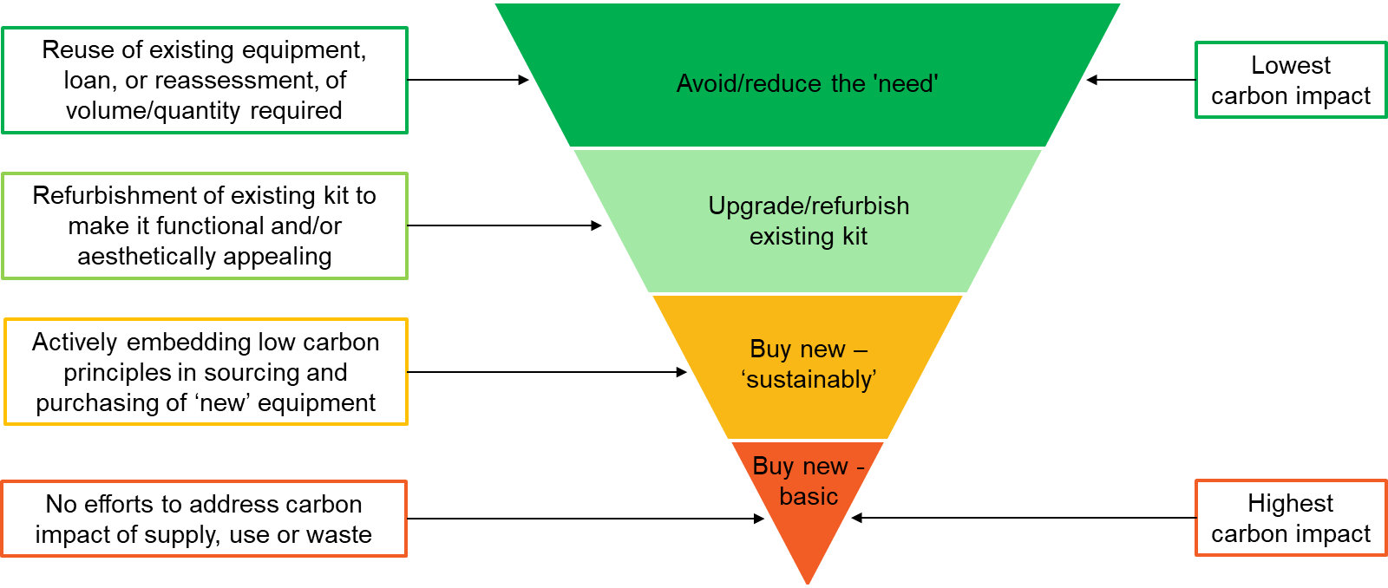

4. Current Arrangements and Expenditure
While there are existing Direct Awards for Revvity, there is currently nothing in place for this requirement.
Lessons Learned: N/A
5. Stakeholder Engagement
Stakeholder | Consulted ( or n/a) | Resulting Actions
Estates | n/a | n/a
IT | n/a | n/a
Records Management | n/a | n/a
HR (if TUPE in/out of the University applies) | n/a | n/a
Compliance and Risk - Data Protection Officer (if complex data protection issues) | n/a | n/a
Compliance and Risk – Welsh Language Standards | n/a | n/a

6. Market Conditions and Reason for Single tender

Market conditions

There are currently no alternatives. According to their Life Sciences-specific terms and conditions ‘’Revvity informs Customer that KinEASE™ STK Reagent Products are covered by one or more patents and pending patent applications licensed from Millipore Corporation and were made pursuant to a co-development agreement between Millipore and a Revvity entity.’’

Pre-market engagement undertaken

N/A

Proposed Single tender
Whilst not advertising are quotes still going to be sought from other suppliers? | Yes ☐ No ☒

Preferred bidder
REVVITY (UK) LIMITED

Value of Procurement | Transparency process | Procurement Process | Process to be used ()
Below Threshold | Sell2Wales | Direct Award
Over threshold | Sell2Wales | Negotiated Procedure without Prior Publication (Regulation 32)
Over threshold | Sell2Wales | Modification of contracts during their term (Regulation 72)

Justification for Direct Award - below threshold. | Reason () | Details of justification & if a VEAT will be published
Extreme Urgency not of the University’s making
Only available as proprietary /patented articles, services or works with no satisfactory alternative |  | Details of the patent contained within a sole source letter available upon request.  (iii) the protection of exclusive rights, including intellectual property rights.
Compatibility with existing equipment, machinery, systems, or software
Uniformity for collaborative research
Part-exchange or ex-demonstration goods
Mandated on grant award letter/formal grant documentation
Not possible, following advertisement to secure competition
<insert any other – though please note unlikely to be approved as this falls outside policy>

Proposed terms
Terms | Terms to be used () | Relevant supporting information
Framework Call Off
Standard Cardiff terms
Standard Cardiff consultancy terms
Model form construction terms
MDI Master Services Agreement
Supplier Terms |  | Reviewed – no issues, standard 30 day delivery and DDP agreed.

The contract will be signed on behalf of the University by: Natalie Stewart
£25-99K Dir of Fin Ops/CIO

7. Due Diligence

Previous Direct Awards
Has this procurement been subject to previous direct award? | Yes ☐ No ☒
If yes | Date: |  | Value: | £
Is this requirement likely to be required again in the future and what plans are in place to mitigate the risk of a further direct award request? | There are no plans, as there’s currently no basis for competition.

Financial due diligence
Dun and Bradstreet Score | 3 (48)
Detail other method if no D&B available

Conflict of Interest Forms
Individual | COI Received () | COIs Identified / declared
Harry Morris |  | None identified
Sara Davies |  | None identified

8. Impact & Savings - L - Laboratory/Animal House Supplies & Services
8.1 Environmental, Social and Governance (ESG) Impact | - ESG Risks  Resource Sourcing, Use, and Disposal – the blood extraction kits are a consumable, meaning there’s potential for waste from sourcing and disposal  Hazardous Materials – Hazardous waste is of minimal risk, as the only potential hazardous material is blood, which poses a low risk  Transparency, Accountability, and Best Practice – very low risk, as Revvity have a peer percentile average of 71 to 90, and a Dun and Bradstreet governance score of 1. More information can be requested through provision of the aforementioned Dun and Bradstreet report  - ESG Opportunity  Resource Sourcing, Use, and Disposal – Revvity adhere to the Waste Electrical and Electronic Equipment (WEEE) Directive, meaning that they routinely recycle their own products at their end-of-life to minimise waste  Hazardous Materials – Revvity adhere to the directives on Restriction of the Use of Certain Hazardous Substances in Electrical and Electronic equipment (RoHS) and Waste Electrical and Electronic Equipment (WEEE), minimising the already low risk  - Whole Life Costing  The product is a consumable, but the company has a local branch in Llantrisant that can deliver, minimising risk and cost of any delivery requirements.  Disposal is handled by Revvity upon the delivery of the goods to Revvity by the buyer. They handle the disposal and/or recycling/repurposing of consumable and non-consumable goods.  Any servicing it out of scope of this contract, as the contract only covers the consumables (blood extraction kits).
8.2 Comparison to budget | Budget – £36,736.8  Price of preferred bid – £30,614 exc VAT
8.3 Secured Saving (ex VAT) & Savings Category (as per savings methodology) | N/A
8.4 Saving calculation | N/A
8.5 Additional Points to note | N/A

Savings Approval
Position | Name | Email Authorisation received | Date
Evaluator / Customer Lead | n/a
Financial Approver | n/a
Head of School/ Department | n/a
Category Manager | n/a
Senior Category Manager (approval of savings up to £500k) | n/a
Director of Procurement (approval of savings over £500k) | n/a

9. Summary Procurement Timetable

Stage of procurement | Deadline Date/time
Receipt of quotes from bidders | Complete
Approval of DA | 14/02/2025
Publishing of Award Notice | 14/03/2025

10. Contract Implementation / Management

Exit Plan for existing Contract – no existing contract in place

Transition to new supplier – this is a new purchase, there is no transition

TUPE Implications – N/A

Delivery – ‘’Notwithstanding the foregoing and unless otherwise indicated on Revvity’s quotation, for Reagent Products sales within Australia, the UK, or any European Union country, such Reagent Products are shipped DDP (Incoterms 2020) and Revvity is responsible for all transportation, shipping and handling charges to the Delivery Point. ‘’ - Terms and Conditions of Sale for Life Sciences

11. Approval

Procurement Plan Written by: Harry Morris

Position | Name | Signed | Date
Procurement Lead | Harry Morris | 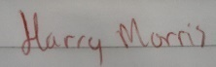 | 10/02/2025

Procurement Plan Approved by: Jamie Jones

Position | Name | Email Authorisation received | Date
Customer Lead | Sarah Davies |  | 03/03/2025
Financial Approver | James Walters |  | 03/03/2025
Head of School/ Department | Rachel Errington |  | 19/03/2025
Senior Category Manager (approval of procurement process up to £99,999) | Jamie Jones |  | 18/02/2025
Procurement Director (approval of procurement process £100k upwards) | N/A
Head of Finance (if £100k or above approval of budget availability) | N/A
Director of Financial Operations (if £500k or above approval of budget availability) | N/A

12. Version Control. This table should be completed in order to track any changes made to the document.
Version | Author | Action/Changes | Date
1 | Harry Morris | Population of document | 10/02/2025
2 | Harry Morris | Revision of document | 11/02/2025

