Direct Award Process
1. Procurement Summary Information
Contract Title: | RiVR Fusion VR Kit
Tender Number: | CU.1867.HM
Authority Name and Address: | Cardiff University, Main Building, Cathays Park, Cardiff CF10 3AT.
Estimated Contract Value over maximum term (ex vat): <Detail term> | £ 35,496.00 | Budget (inc vat where applicable): |  | £ 42,595.2
Forecast Saving (ex VAT) and Category: | N/A
Risk Rating (for contracts valued £100k and above) – see Appendix 1: | N/A
Procurement Lead: | Harry Morris
Key Project Stakeholders: | Name: |  | Project Role  e.g., Customer Lead/Technical contact/evaluator/H&S Lead
Key Project Stakeholders: | Rhian Morgan |  | Customer Lead
Head of School/Dept: | Rachel Errington
Financial Approver: | Sherrie Witts
Funding Source: | Genomics Partnership Wales/Welsh Government | Budget Code: |  | GPW 522121

2. Introduction
The requirement is for VR Headsets and training in their use for training regarding the GTEC lab project, of which the English participants are already utilising the training to develop Clinical Trial STP’s without the need for multiple 1:2:1 in person sessions.
Alexandra J Murray – ‘’ RiVR Fusion VR headsets for GPW (Genomics Partnership Wales) including licence fee and training. The equipment needs to be exactly the same VR ‘kit’ as the Genomics Units use in England’’
RiVR definition of product - - ‘’Computer programs that allow the Customer to view videos or images in 360° virtual reality through synchronised virtual reality headsets and other equipment Genome Training immersive assets’’ – ‘’ Train the trainer RiVR Link Install Train the Trainer for up to 5 attendees at the client location’’
3. The Waste/ Purchase Hierarchy
This is a direct award justified on the basis of compatibility with methods used by our collaborators in England, meaning that there’s no scope to avoid/refurbish/purchase sustainably, as we need to maintain consistency of training methods to maintain speed of training. The product is also patented, meaning that there’s no scope to source this second-hand from anywhere else. The delicate nature of the research would also incentivise using new kit.
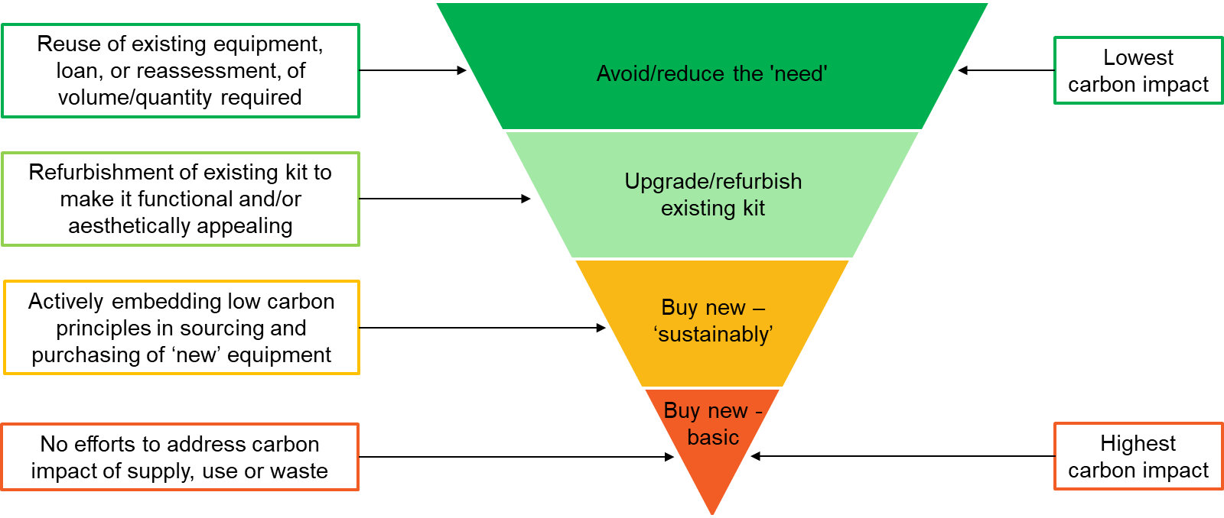

4. Current Arrangements and Expenditure
This will be our first engagement with this supplier; we are setting them up on Oracle especially for this order.
Lessons Learned: N/A
5. Stakeholder Engagement
<complete table below>
Stakeholder | Consulted ( or n/a) | Resulting Actions
Estates | n/a | n/a
IT | n/a | n/a
Records Management | n/a | n/a
HR (if TUPE in/out of the University applies) | n/a | n/a
Compliance and Risk - Data Protection Officer (if complex data protection issues) | n/a | n/a
Compliance and Risk – Welsh Language Standards | n/a | n/a

6. Market Conditions and Reason for Single tender

Market conditions
This is a patented product, so there is currently no basis for market competition.

Pre-market engagement undertaken
n/a

Proposed Single tender
Whilst not advertising are quotes still going to be sought from other suppliers? | Yes ☐ No ☒

Preferred bidder
Reality in Virtual Reality Limited

Value of Procurement | Transparency process | Procurement Process | Process to be used ()
Below Threshold | Sell2Wales | Direct Award
Over threshold | Sell2Wales | Negotiated Procedure without Prior Publication (Regulation 32)
Over threshold | Sell2Wales | Modification of contracts during their term (Regulation 72)

Justification for Direct Award - below threshold. | Reason () | Details of justification & if a VEAT will be published
Extreme Urgency not of the University’s making
Only available as proprietary /patented articles, services or works with no satisfactory alternative |  | Details of the patent contained within a sole source letter available upon request.  (iii) the protection of exclusive rights, including intellectual property rights.
Compatibility with existing equipment, machinery, systems, or software
Uniformity for collaborative research
Part-exchange or ex-demonstration goods
Mandated on grant award letter/formal grant documentation
Not possible, following advertisement to secure competition
<insert any other – though please note unlikely to be approved as this falls outside policy>

Proposed terms <complete table below>
Terms | Terms to be used () | Relevant supporting information
Framework Call Off
Standard Cardiff terms |  | Agreed to our terms as per our New Supplier Form
Standard Cardiff consultancy terms
Model form construction terms
MDI Master Services Agreement
Supplier Terms

The contract will be signed on behalf of the University by: Natalie Stewart
£25-99K Dir of Fin Ops/CIO

7. Due Diligence

Previous Direct Awards
Has this procurement been subject to previous direct award? | Yes ☐ No ☒
If yes | Date: |  | Value: | £
Is this requirement likely to be required again in the future and what plans are in place to mitigate the risk of a further direct award request? | There is an ongoing 4k per year charge, so we will pick this up in our DA report to periodically check whether or not we can arrange a lower aggregate price.

Financial due diligence
Dun and Bradstreet Score | 3 (Low Risk)
Detail other method if no D&B available

Conflict of Interest Forms <must be completed y all involved in procurement process>
Individual | COI Received () | COIs Identified / declared
Nina Lazarou
Rhian Morgan |  | No conflicts identified

8. Impact & Savings
8.1 Environmental, Social and Governance (ESG) Impact | - ESG Risks  Resource Sourcing, Use, and Disposal – There is a disposal risk with this product, as there is long term intended use for these products, ultimately leading to replacement and disposal requirements for CU users.  Modern Slavery – this is a generic risk associated with the industry, but there are no facets of RiVR that insinuate a greater risk than industry average  Working Conditions/Health and Safety – this is a generic risk associated with the industry, but there are no facets of RiVR that insinuate a greater risk than industry average  Transparency, Accountability, and Best Practice – this is a generic risk associated with the industry, but there are no facets of RiVR that insinuate a greater risk than industry average  - ESG Opportunity  Most of the issue stipulated above can be covered off by RiVR’s positive ESG rating on DNB, with only their social score being blow industry average.  The size of the initial purchase is relatively quite low for the cost and has a low rate of consumables associated with the use of the product itself, lowering the risk of resourcing use and disposal issues.  - Whole Life Costing  As long as the annual licence is subscribed to, all RiVR products are covered under full warranty, providing indefinite security to our customers. Training is included in the initial cost, and there are currently no disposal plans, as the use of the product will be ongoing, as will its warranty.
8.2 Comparison to budget | Budget – excl. VAT - -£ 35,496.00  Price of preferred bid – excl. VAT - £ 42,595.2
8.3 Secured Saving (ex VAT) & Savings Category (as per savings methodology) | N/A
8.4 Saving calculation | N/A
8.5 Additional Points to note | N/A

Savings Approval
Position | Name | Email Authorisation received | Date
Evaluator / Customer Lead | n/a
Financial Approver | n/a
Head of School/ Department | n/a
Category Manager | n/a
Senior Category Manager (approval of savings up to £500k) | n/a
Director of Procurement (approval of savings over £500k) | n/a

9. Summary Procurement Timetable
<complete summary below – leave in relevant lines where waiving competition>

Stage of procurement | Deadline Date/time
Receipt of quotes from bidders | Complete
Approval of DA | 13/01/2025
Contract mobilisation | 14/03/2025

10. Contract Implementation / Management

Exit Plan for existing Contract – no existing contract in place

Transition to new supplier - this is a new purchase, there is no transition

TUPE Implications - N/A

Delivery – PO already placed by customer and agreed with supplier

11. Approval

Procurement Plan Written by: Harry Morris

Position | Name | Signed | Date
Procurement Lead | Harry Morris | 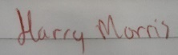 | 07/03/2025

Procurement Plan Approved by: <delete if a capital project>

Position | Name | Email Authorisation received | Date
Customer Lead | Nina Lazarou
Financial Approver | Rhian Morgan
Head of School/ Department | Rachel Errington
Senior Category Manager (approval of procurement process up to £99,999) | Jamie Jones
Procurement Director (approval of procurement process £100k upwards) | N/A
Head of Finance (if £100k or above approval of budget availability) | N/A
Director of Financial Operations (if £500k or above approval of budget availability) | N/A

12. Version Control. This table should be completed in order to track any changes made to the document.
Version | Author | Action/Changes | Date
07/03/2025 | Harry Morris | Population of document | 07/03/2025
19/03/2025 | Harry Morris | Submission of document to Jamie Jones for approval | 19/03/2025

