Direct Award Process
1. Procurement Summary Information
Contract Title: | T1D-Plus study with Dexcom
Tender Number: | CU.1863HM
Authority Name and Address: | Cardiff University, Main Building, Cathays Park, Cardiff CF10 3AT.
Estimated Contract Value over maximum term (ex vat): | £ 76,000 exc VAT | Budget (inc vat where applicable): |  | £ £78,000
Forecast Saving (ex VAT) and Category: | N/A
Risk Rating (for contracts valued £100k and above) – see Appendix 1: | N/A
Procurement Lead: | Harry Morris
Key Project Stakeholders: | Name |  | Project Role  e.g., Customer Lead/Technical contact/evaluator/H&S Lead
Key Project Stakeholders: | Colin Dayan |  | Customer Lead
Key Project Stakeholders: | Rachel Deere |  | Customer
Key Project Stakeholders: | Julia Townson |  | Customer
Head of School/Dept: | Prof Rachel Errington
Financial Approver: | Julia Townson
Funding Source: | JDRF (Juvenile diabetes research foundation)/Helmsley Charitable Trust | Budget Code: |  | 522263/524873

2. Introduction
T1D-Plus trial is a randomised, adaptive, open label, parallel group, multi-centre Platform trial in adults with newly diagnosed type 1 diabetes). The T1D Plus trial, funded by JDRF, sponsored by CU, started on 30th September 2022, led by Colin Dayan. Since that time, additional arms of the trial have been funded by separate grants from the Helmsley Charitable Trust and JDRF Australia. Funding was agreed in Dec 2023.
An endpoint in the trial is the recording of glucose levels by a continuous glucose monitoring device. These devices are marketed by different companies with different specifications.

3. The Waste/ Purchase Hierarchy
This is a direct award justified on the basis of research uniformity and consistency, meaning that there’s no scope to avoid/refurbish/purchase sustainably, since it would compromise the standardisation of research design.

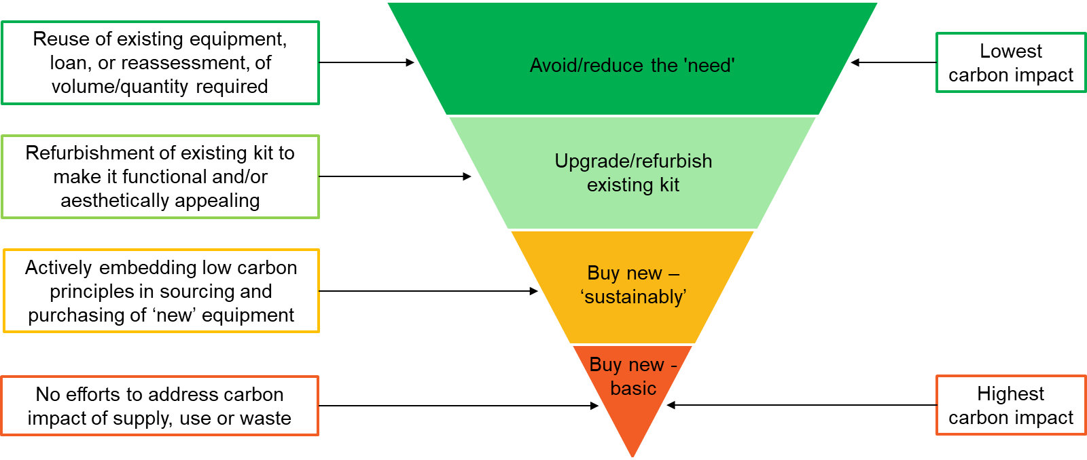

4. Current Arrangements and Expenditure
This is a follow-on from previous research; this is the first engagement for this requirement.
Lessons Learned: N/A
5. Stakeholder Engagement

Stakeholder | Consulted ( or n/a) | Resulting Actions
Estates | N/A | N/A
IT |  | Assess as low risk – no further review required by University IT. Data protection office happy that no personal data is being processed.
Records Management | N/A | N/A
HR (if TUPE in/out of the University applies) | N/A | N/A
Compliance and Risk - Data Protection Officer (if complex data protection issues) | N/A | N/A
Compliance and Risk – Welsh Language Standards | N/A | N/A

6. Market Conditions and Reason for Single tender

Market conditions

*Taken from Colin Dayan’s initial request

• For collaborative research, whereby the equipment required must be the same as that of Research Partners to ensure uniformity and coherence of research outputs and results with an approved waiver

The current trial is closely linked to the Ver-A-T1D trial which is currently ongoing and which used the Dexcom system for Continuous Glucose monitoring. Ver-A-T1D compared verapamil with placebo. The T1D plus study will compare Verapamil alone with combinations of verapamil and other drugs in patients with the same condition and of the same age as Ver-A-T1D. There is no placebo arm in T1DPlus as the intention was use the data from Ver-A-T1D to estimate differences with placebo.

Different continuous glucose monitoring systems have different detection parameters and cannot be directly compared. In order to compare the continuous glucose monitoring data in the T1D Plus study with the sister Ver-A-T1D study, monitors using the same technology are required. For this reason we request to use Dexcom again in T1D Plus consistent with the criteria:

"For collaborative research, whereby the equipment required must be the same as that of Research Partners to ensure uniformity and coherence of research outputs and results with an approved waiver"

Pre-market engagement undertaken
As this requirement can only be provided by the above supplier, no further market research has been undertaken.

Proposed Single tender
Whilst not advertising are quotes still going to be sought from other suppliers? | Yes ☐ No ☒

Preferred bidder
Dexcom International
Value of Procurement | Transparency process | Procurement Process | Process to be used ()
Below Threshold | Sell2Wales | Direct Award
Over threshold | Sell2Wales | Negotiated Procedure without Prior Publication (Regulation 32)
Over threshold | Sell2Wales | Modification of contracts during their term (Regulation 72)

Justification for Direct Award - below threshold. | Reason () | Details of justification & if a VEAT will be published
Extreme Urgency not of the University’s making
Only available as proprietary /patented articles, services or works with no satisfactory alternative
Compatibility with existing equipment, machinery, systems, or software
Uniformity for collaborative research |  | Uniformity with existing research methods.  Exemption from competition down to –  Regulation 32 (2) (b) (ii) competition is absent for technical reasons.
Part-exchange or ex-demonstration goods
Mandated on grant award letter/formal grant documentation
Not possible, following advertisement to secure competition

Proposed terms
Terms | Terms to be used () | Relevant supporting information
Framework Call Off
Standard Cardiff terms
Standard Cardiff consultancy terms
Model form construction terms
MDI Master Services Agreement
Supplier Terms
Research and Innovation Services research trial terms and conditions |  | Headed by Teresa Bowen

The contract will be signed on behalf of the University by: Natalie Stewart
£25-99K Dir of Fin Ops/CIO

7. Due Diligence

Previous Direct Awards
Has this procurement been subject to previous direct award? | Yes ☐ No ☒
If yes | Date: |  | Value: | £
Is this requirement likely to be required again in the future and what plans are in place to mitigate the risk of a further direct award request? | There aren’t any plans to reconduct this study as of yet. Early engagement with Procurement has been encouraged to ensure savings can be explored where possible.

Financial due diligence
Dun and Bradstreet Score | Not Available (foreign supplier)
Detail other method if no D&B available | Negative Acid Test ((current assets – inventories)/Current Liabilities) based on 2023-2022 accounts. Approval provided by Jamie in light of low order value and no prepayment requirement.

Conflict of Interest Forms
Individual | COI Received () | COIs Identified / declared
Colin Dayan |  | None identified
Julia Townson |  | None identified
Rachel Deere |  | None identified

8. Impact & Savings
8.1 Environmental, Social and Governance (ESG) Impact | - ESG Risks  Modern Slavery has been identified as a risk under this category. However, it is loosely applicable to this requirement since large and there is a chance that tertiary suppliers source materials from suppliers that are at risk of modern slavery abuses, and that materials Dexcom use may have a link to modern slavery.  Dexcom actively audit their supply chain and consistently map out their supply chain to ensure ethical sourcing as per the ‘Dexcom Statement on Compliance with California Transparency in Supply Chains Act and U.K. Modern Day Slavery Act’.  Working Conditions/Health and Safety are covered underneath Dexcom’s Modern Slavery act, referencing measures taken to protect workers as well as ensure their safety whilst reporting violations, which includes vendors within their own supply chain.  Transparency, Accountability, and Best Practice aren’t directly accounted for by a single statement of policy released by Dexcom, but they have a very high social governance score of 2 under their Dun and Bradstreet report.  - ESG Opportunity  There are limited direct opportunities identified within this contract. However, the overall outcome of using these products is being used to aid in diabetes research and treatment, and the risk is mitigated through their existing modern slavery policy.  - Whole Life Costing  There are no alternatives to this supplier. The consumables required for this trial will be used only for research, and once concluded will be disposed of in a responsible manner by the University. There are no service or maintenance requirements during its life cycle. All costs of delivery associated are include in the price.
8.2 Comparison to budget | Budget – £ 76,000 exc VAT  Price of preferred bid – £ 76,000 exc VAT
8.3 Secured Saving (ex VAT) & Savings Category (as per savings methodology) | N/A
8.4 Saving calculation | N/A
8.5 Additional Points to note | N/A

Savings Approval
Position | Name | Email Authorisation received | Date
Evaluator / Customer Lead | N/A
Financial Approver | N/A
Head of School/ Department | N/A
Category Manager | N/A
Senior Category Manager (approval of savings up to £500k) | N/A
Director of Procurement (approval of savings over £500k) | N/A

9. Summary Procurement Timetable

Stage of procurement | Deadline Date/time
Receipt of quotes from bidders | Completed
Approval of DA | 12/02/2025
Contract Award Notice | 12/03/2025

10. Contract Implementation / Management

Exit Plan for existing Contract – no existing contract

Transition to new supplier – no previous supplier

TUPE Implications – N/A

Delivery – as outlined in contract

11. Approval

Procurement Plan Written by: Harry Morris

Position | Name | Signed | Date
Procurement Lead | Harry Morris | 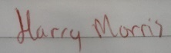 | 05/02/2025

Procurement Plan Approved by: Jamie Jones

Position | Name | Email Authorisation received | Date
Customer Lead | Colin Dayan
Financial Approver | Sarah Debattista
Head of School/ Department | Rachel Errington
Senior Category Manager (approval of procurement process up to £99,999) | Jamie Jones
Procurement Director (approval of procurement process £100k upwards) | N/A
Head of Finance (if £100k or above approval of budget availability) | N/A
Director of Financial Operations (if £500k or above approval of budget availability) | N/A

12. Version Control. This table should be completed in order to track any changes made to the document.
Version | Author | Action/Changes | Date
1 | Harry Morris | Initial population of document | 31/01/2025
2 | Harry Morris | Amendment to document | 05/02/2025
3 | Harry Morris | Final checks after receipt of agreement from legal | 04/03/2025

