Tender Notice for
The Provision of Operated Plant

Issue Date: 16/01/2026
Closing Date and Time: 10/02/2026 - 5pm

NGN Primary Contact: Elle Flood
eflood@northerngas.co.uk

NGN Secondary Contact: Joanna Palmer
jpalmer@northerngas.co.uk

Contents
Guidance. Please read carefully on how to proceed with event 3
Introduction…………………………………. 4
Northern Gas Networks Geographic Area 5
NGN Core Values 5
Scope of Requirements 6

Guidance
This Tender Notice is issued by Northern Gas Networks (NGN) and is live until 10/02/2026 at 5pm.
The aim of this Tender Notice is to:

* Ensure we provide bidders with adequate information to determine if they wish to proceed with this tender event.

* Provide NGN with a more detailed understanding of the interest within the market.

The Tender Notice process is the first stage of multistage procurement process.
All interested suppliers must follow the below steps in order to proceed with the conditions of participation and PQQ stages of this procurement event:

Sign up or Sign in to NGNs Tendering Portal – Market Dojo. Follow this link to do so: sign-up - Market Dojo

When you have logged in to your dashboard, you'll need to click the 'Show all or enter invite code' button under the Event Invitations section, as per below screenshot:
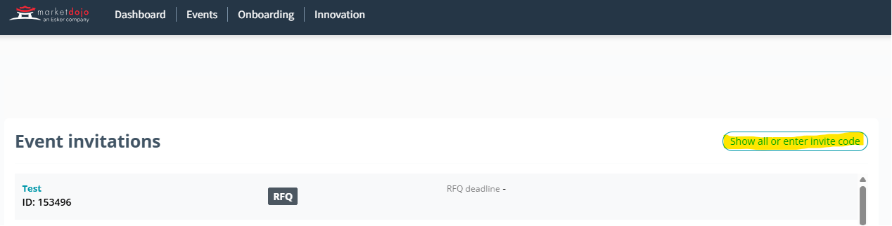

You’ll need to enter this code: 5200B8C9D2

It will then notify NGN to approve you onto the tender event. Once approved you will be given access to the event, where you’ll be taken to the Conditions of Participation stage, this stage is a pass/fail and will be locked until after the PQQ submission deadline. Any supplier who fails this stage will automatically be withdrawn from the process and will not gain access to the PQQ. All suppliers who pass this stage will be automatically taken to the PQQ where they will be given a deadline and detail to complete.

Once the PQQ has been evaluated by NGNs internal evaluation team all those who meet the criteria will be sent to the RFP stage where NGN will assess against award criteria.

Introduction

Northern Gas Networks Limited (NGN) is the company responsible for distributing gas to homes and businesses across the North of England. As part of the restructuring of the gas distribution business in England, NGN successfully acquired the North of England gas Distribution Network (DN) and took control of the assets on 1st June 2005. NGN has been responsible since then for the transportation of gas to the North of England via 36,000Km of pipelines.

The DN is located in the North of England and extends south from the Scottish border to South Yorkshire and has coastlines on both the East and West sides of the region. The DN contains a mixture of large cities such as Newcastle, Middlesbrough, Leeds and Bradford and a significant rural area including North Yorkshire and Cumbria. The area covers around 6.7 million inhabitants and has approximately 2.5 million customers. The DN is supplied via 23 off takes from the national Transmission System.

Northern Gas Networks Geographic Area

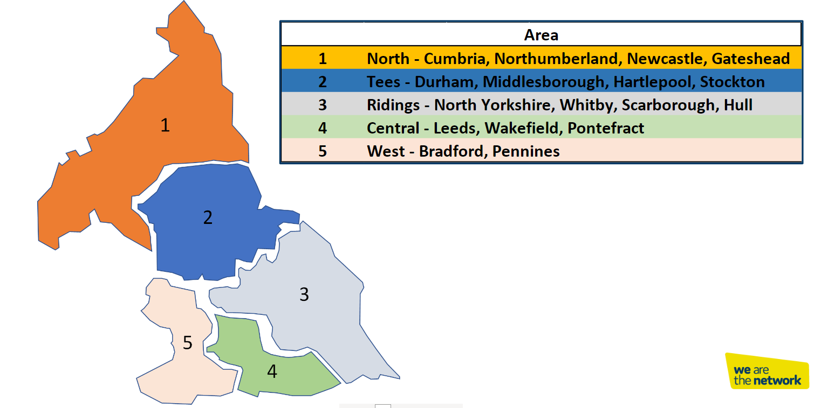

NGN Core Values

NGNs dream is to become the UK’s most loved, admired and respected company, and to establish a reputation for doing business really well through a united and empowered team that is mind-blowingly great. We recognise the important role that our supply chain partners having in supporting NGN to achieve our dream.

Our dream lies at​​ the centre everything we do and has been translated into a unique set of values that reflect and reinforce our culture.
- Trailblazing
- Intellectually Curious
- Community Focused
- Empowered
- Heartfelt
- Happy

Every member of our team is passionate about the contribution they make to our growing reputation as a pioneering, effective, conscious and enlightened business that is focused on changing the way that things are done.

We expect our suppliers to share our vision and values and our way to support NGN in achieving our goals.

Scope of Requirements

Introduction
Northern Gas Networks (NGN) requires multiple Operated Plant Services to support its Emergency, Locate and Repair (ELR) Teams for non-planned gas escapes across the network. NGN operates approximately 170 ELR teams, attending circa 120,000 response and repair jobs annually, and may require Operated Plant Services at any time.
NGN also anticipates requirements for Operated Plant Services to support:
- Connections Division: Connecting over 10,000 customers annually, including new builds, disconnections, and service alterations
- Planned Replacement Programme: Delivering 540 km of mains and 44,000 services per year.
The services will be provided under a Framework Agreement on a call-off basis, ensuring availability 365 days a year, 24/7, to maintain safety, productivity, compliance, and customer care.

Service Requirements

General Requirements
The Supplier shall provide operated plant hire services to support the NGN’s Operational and maintenance projects. All plant and operators must meet the standards set out in this Scope of Services.
- All plant hires to be provided on an ad hoc / call-off basis.
- Plant will be required to be delivered to site
- Emergency requests: Plant and operator to be on NGN site within 4 hours of request.
- Pre-booked requests: Delivery within 24 hours.
- Equipment must:
  - Be fit for purpose, fully serviced, and delivered in full working order.
  - Meet highway specification and include flashing beacons.
  - Comply with all relevant statutory requirements, including emissions and noise regulations.
- Supplier responsibilities:
  - Routine maintenance of equipment.
  - Transport, fuel, and ancillary services.
  - Provision of PPE and tools for operatives.
  - Workforce management and compliance with NGN policies.

Specific Service Categories

Mobile Elevated Work Platforms (MEWP)
- Types: Van-mounted cherry pickers, scissor lifts, access platforms, aerial platforms.
- Minimum capacity: 2 persons, height up to 3 storeys.
- Operators must hold:
  - Valid SHEA Gas Passport.
  - Relevant training and full driving licence.
- NGN may request operator competence sessions prior to equipment release.

JCBs & Dumpers
- JCB/Dumper/Breaker trucks (including 360° rotation).
- Dumper sizes: 3TN, 5TN, 8TN, 10TN (forward tipping swivel).
- Operators must hold:
- valid SHEA Gas Passport
- demonstrate experience with buried plant.

Road Sweeping / Gully Sucker / Vacuum Excavating / Snow Clearing
- Road sweepers: Remove debris, dirt, litter; maintain clean roadways.
- Gully suckers: clean drainage systems, equipped with high-pressure jetting and large waste tanks.
- Vacuum excavators: Safely expose buried utilities, remove soil/debris, fitted for varied conditions.
- Operators must hold:
- valid SHEA Gas Passport
- relevant licences

Grab Waggons
- Sizes: 18T, 26T, 32T.
- Operators must hold:
- valid SHEA Gas Passport
- HGV licences & CPS licences

Crane Hire & Lifting Operations
- Cranes of varying sizes (details to follow).
- Operators must be competent and qualified.

All plant hire provided is required on an ad hoc / call off basis and will need to be available 7 days a week 24 hours a day. Emergency requests to be available and on NGN site within 4 hours of the initial request and pre-booked requests within 24 hours.

All plant hire provide should be fit for purpose with full-service history and delivered in full working order at highway specification, with corresponding flashing beacons. Routine maintenance is the sole responsibility of the supplier.
Suppliers are expected to agree to the following KPI’s.
KPI | Overview | Target
Delivery - Emergency | Emergency call-out response to unforeseen incidents (e.g., gas escapes). Supplier to be onsite within 4 hours of request. | 95%
Delivery - Planned | Pre-booked requests for planned projects. Supplier to deliver plant and operator within 24 hours of request. | 95%
Equipment Availability | All hired plant to be delivered in full working order, fit for purpose, and compliant with highway specification. | 95%
Operator Competence | All operators to hold valid SHEA Gas Passport and relevant licences. Evidence of training and competence provided prior to deployment. | 100%
Compliance Documentation | Risk Assessment and Method Statement (RAMS) provided for all lifting operations and high-risk activities. | 100%

These KPIs are a rough guidance at this stage and subject to change. KPIs will be fully defined at RFP stage included in Contract Challenge section.

