The Windsor Boys School - D Block Roof Replacement

Full replacement of D Block Roof – Quotes required by 12 noon 19th May 2025. All works to be guaranteed for 30 years.
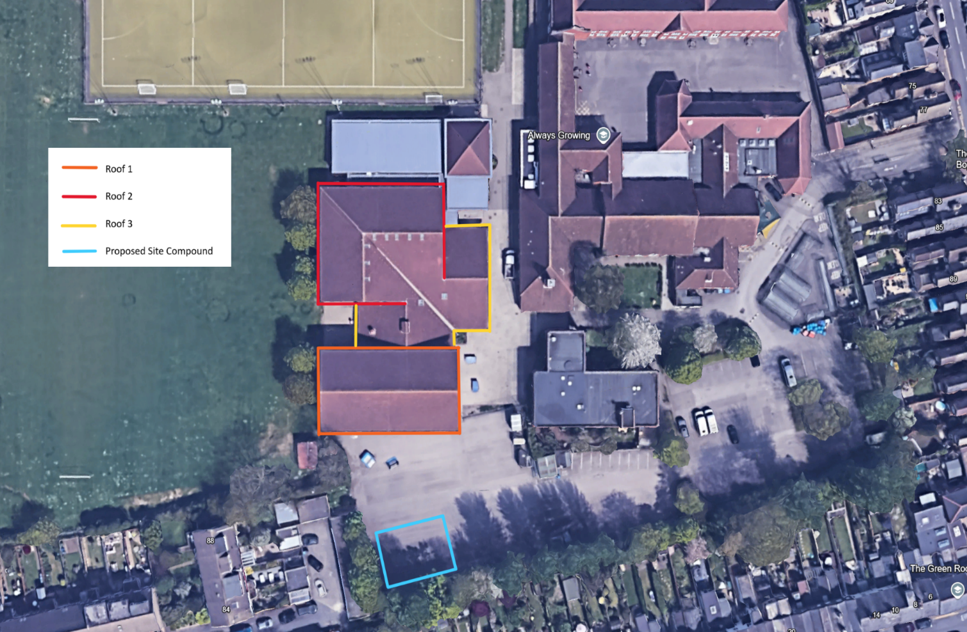

Description | Unit Price
Preliminaries:
Health & Safety documentation, Welfare, Site compound, Skips.

Roof 1 - 800m2

Scope of works:
- Strip existing tiles, felt & batten, renew with premium treated BS5534 – compliant batten and install new high-quality breathable membrane.
- Renew tiles with Redland Concrete Regent tiles.
- Renew ridge tiles with Redland Concrete half-round ridge tiles and dry ridge kit.
- Install new eaves trays, fascia vents and comb fillers.
- Clear all waste and debris from site.
- Scaffolding

Roof 2 – 920m2

Scope of works:
- Strip existing tiles, felt & batten, Renew with premium treated BS5534- compliant batten and install new high-quality breathable membrane.
- Renew tiles with Redland Concrete Regent tiles.
- Renew ridge/hip tiles with Redland Concrete half-round ridge/hip tiles and dry ridge kit.
- Remove existing verge & install new dry verge unit with end caps.
- Remove existing valley & install new dry valley trough.
- Install new eaves trays, fascia vents & comb fillers.
- Replace all lead flashing as required.
- Clear all waste & debris from site.
- Scaffolding
- Remove existing Velux rooflights and install 8no PK08 & 3no FPK08 Velus units with associated flashings.

Roof 3 – 520m2

Scope of works:
- Strip existing tiles, felt & batten, Renew with Premium treated BS5534- compliant batten and install new high-quality breathable membrane.
- Renew tiles with Redland Concrete Regent tiles.
- Renew ridge/hip tiles with Redland Concrete half round ridge/hip tiles and dry ridge kit.
- Remove existing verge & install new dry verge unit with end caps,
- Install new eaves trays, fascia vents & comb fillers.
- Clear all waste and debris from site.
- Scaffolding

170 x metal box gutters

