‘REDISCOVERING TAVISTOCK ABBEY PROJECT’
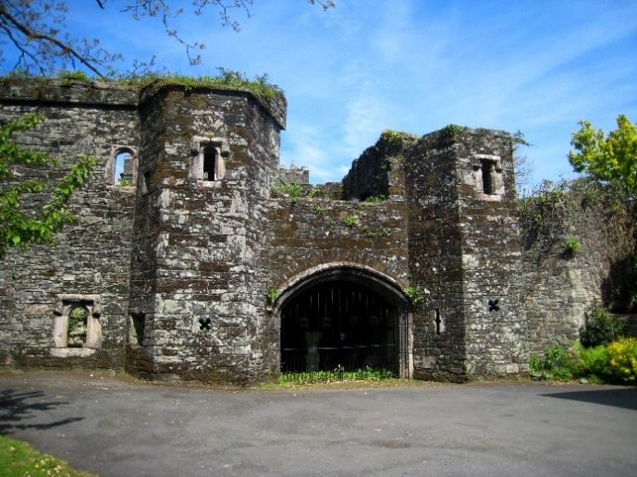
Betsy Grimbal’s Tower
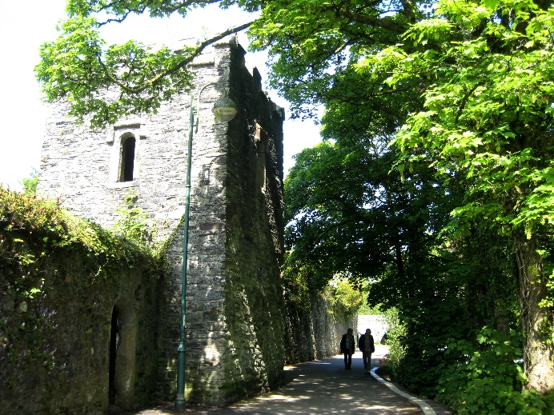
The Stillhouse

BRIEF
FOR THE APPOINTMENT OF A CONSERVATION ARCHITECT FOR THE REPAIRS WORKS TO THE STILLHOUSE AND BETSY GRIMBAL’S TOWER, TAVISTOCK, WHICH FORMS PART OF THE ‘REDISCOVERING TAVISTOCK ABBEY PROJECT’

- Summary
Tavistock Town Council as Client and Accountable Body invites tenders from an AABC or equivalent Conservation accredited Architect with the relevant skills and capability in heritage and conservation projects to take the lead role for the grant funded repair, refurbishment and new public access, lighting and signage enhancement of Betsy Grimbals Tower (Grade 1 (No.1326209)) and Still House (Grade 2 (No.1105870)) buildings located on Plymouth Rd in the town centre.

Provided on Tavistock Town Council website to assist with the submission are elevation drawings, conditions surveys, archaeologist report and budget estimates for the work.
The budget allowance for this project for Architects fees is up to £30,000 plus VAT.
The capital costs for the works in total are estimated between the range of £325,000-£375,000 plus VAT. In addition an allowance excluding VAT has been made for Structural Engineer (£3,700), Archaeologist (£16,000) and Ecologist (£5,000).
The Architects roles and responsibilities under RIBA stages 3-7 include Contract Administration of the capital grant funded fabric works which will be executed under a RIBA or JCT Building Contract as well as liaison and contract management of other appointed professional consultants listed above. During the construction phase on Betsy Grimbals Tower there will also be two skills day workshops and an archaeological dig project co-ordinated by Tavistock Heritage Trust. Other tasks include the production of tender documents, tender evaluation and report, liaison with client throughout, capital progress meeting coordination (please outline allowance within your submission) and production of 5 year maintenance plan on completion of works.
The timelines include: letting of Conservation Architect Contract end of January 26, anticipated June start date for capital works, completion date for capital works mid-November 26.
- Overview
The above is part of the Rediscovering Abbey Remains Project. The objectives are wide and diverse; part of which is to ensure the continuous repair and care of the Tavistock Abbey remains. Further elements of the project include extensive archaeological investigations, research into the abbey and its life and power and the creation of AV interpretation of the finds and research. They will ensure long term interest both from the local community and visitors, and provide knowledge of the abbey, which until now has been rather piecemeal, and will aim to create an educational resource for schools and research. The capital works relating to the repairs will be managed by the Tavistock Town Council who own the two substantial abbey remains. The Town Council are in partnership with the Tavistock Heritage Trust who will be managing the remaining elements of the project relating to research and interpretation.
Tavistock Abbey is a Scheduled Monument SAM 1020401 Betsy Grimbal’s Towers is Listed Grade I and is on the At Risk Register, category C (slow decay; no solution agreed). The Stillhouse is Listed Grade II located within the curtilage of the garden of the Bedford Hotel and Tavistock Vicarage garden and borders the abbey’s precinct wall abutting the River Tavy. Betsy Grimbal’s Tower borders Plymouth Road, the entrance to the Bedford Hotel carpark and the Tavistock Vicarage parking area. Both buildings are in the ownership of the Tavistock Town Council. Information about the Tavistock Town Council is available on www.tavistock.gov.uk, and the Tavistock Heritage Trust on www.heritageintavistock.org.

- Submission requirements
Applicants should note that submission should be made by post and must be received no later than the stated deadline. It is the tenderers responsibility to ensure that their tenders arrive at the office address and by this date and time. Tavistock Town Council does not undertake to consider late tenders.
If you are interested in tendering for this project please return your tender in writing in a sealed envelope by no later than midday 29th January 26 marked:
CONFIDENTIAL – REDISCOVERING TAVISTOCK ABBEY PROJECT to:
The Proper Officer,
Tavistock Town Council,
Town Council Offices, Drake Road,
TAVISTOCK, Devon, PL19 0AU.
For tender enquiries please contact Wayne Southall on 01822 616134 or via email wayne.southall@tavistock.gov.uk
For site access please contact Becky Rowe on 01822 616134 or via email becky.rowe@tavistock.gov.uk
Note – prospective tenderers are prohibited from contacting staff or councillors to canvass or encourage support for their tender outside of the prescribed process.
The tenders will be assessed 50% price, 50% technical return.

The submission should include a financial breakdown of the project stages listed above and an indication of the estimated allocation allowed for relating to meetings/site attendance.

The technical return should include an outline methodology for delivering the project scope, evidence Professional Indemnity Insurance, schedule of stage payments, QA documentation relating to key personal and comms arrangements, two suitable references and evidence of experience in delivering three conservation projects of a similar scope/size.

